The Arts 1: What is an artist? Can I be one?

Key Vocabulary |  | What should I already know?  How to join simple materials together using glue, tape and paint.  Simple painting and blending techniques.  How to shape simple forms using plasticine and playdoh by moulding, squashing, cutting and pressing.  In Year One- Art 2  Four Cornish artists and creators: Hepworth, Frost, Lanyon and Leach.
Art
Artist
weave
warp
weft
loom
yarn
abstract
drip style
djembe
compose
samba
primary colours
line drawing
mixed media
running stitch
Sewing Techniques and Textiles  Making a pom-pom- https://youtu.be/SXFCO3LBJss  Weaving on a CD- https://www.youtube.com/watch?v=0JIU_B9jl6g |  | Key Experiences  Visit to local art gallery in Fowey- how to stage an exhibition  Visit to Falmouth Art Gallery with workshops in Printmaking and Matisse Flowers.
Music
Instrumental Teaching-  EYFS- Djembe drumming  Y1- Samba drumming  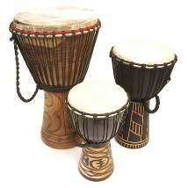 |  | Composition-  https://www.tate.org.uk/kids/games-quizzes/swingaling  Compose a piece to accompany your artwork- using different sounds to represent the different elements of your piece. Work as a group to ‘play’ your art composition.  Close study of music of the 1950’s including Buddy Holly, The Chordettes (including clapping rhythms in Mr Sandman!), Nina Simone, Nat King Cole and Elvis.

Key Artists and their work
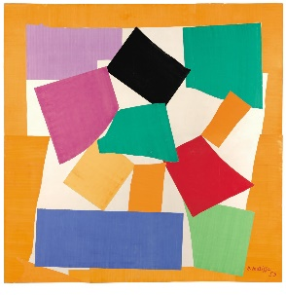  Henri Matisse- The Snail 1953  Henri Émile Benoît Matisse was a French artist, known for his use of colour.  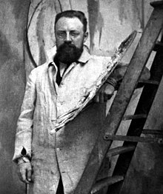  He was a draughtsman, printmaker, and sculptor, but is mostly known as a painter. After 1948, Matisse was too unwell to paint but, although he had to stay in bed, he produced a number of works known as gouaches découpées.  These were made by cutting or tearing shapes from paper which had been painted with gouache. The shapes were placed and pasted down by an assistant working under Matisse's instruction. |  | 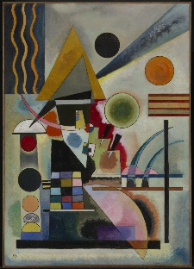  Wassily Kandinsky- Swinging 1925  Wassily Wassilyevich Kandinsky was a Russian painter. He is generally thought of as the pioneer of abstract art.  The work is called ‘Swinging’. He wanted it to show movement.  Kandinsky believed painting should aim to be as abstract as music. He worked to create art that was free from all references to the material world.
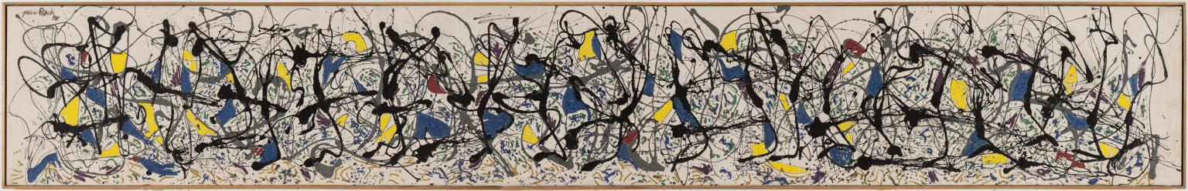

Jackson Pollock- Summertime Number 9A 1948

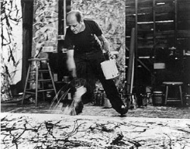  Jackson Pollock was an abstract expressionist artist. The abstract expressionists were a group of young New York artists who made paintings that were non-representational, meaning they didn't look like anything.  Instead they tried to show emotions, like happiness or anger, in the expressive marks that they made in their drawings, paintings and sculptures.  In 1945, Pollock moved from New York City to Long Island. His studio was a converted barn without heating or lighting. Pollock’s aim to work directly from his unconscious led to a radical process of dripping and pouring paint over large canvases placed flat on the ground.  The rhythms in Summertime reflect his belief that ‘The modern artist ... is working and expressing an inner world - in other words expressing the energy, the motion, and other inner forces’.  Some people think that a frieze of figures lies under the abstract web of paint in this work. | 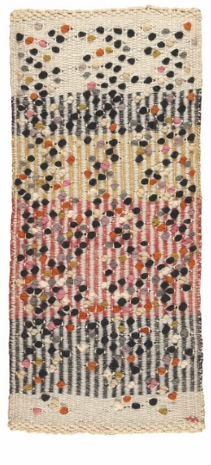  Anni Albers- Dotted 1959  Anni Albers was a German artist. She was born in Berlin in 1899 and came from a Jewish family. She was interested in art from a young age.  Albers studied at the Bauhaus. The Bauhaus was an exciting school of art and design in Germany. Art teachers and students at the school worked and learnt together instead of being told what to do.  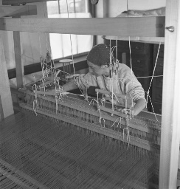  At the time, women were only allowed to study a few classes. Anni decided to study weaving and became one of the greatest textile artists of our time. She believed that textiles are a type of art and as important as painting or sculpture!

