The Arts 4: Can you see the front and the back at the same time?
Impressionism and Post Impressionism
Key Vocabulary |  | What should I already know?  Artworks and craft by four famous artists and four Cornish artists, development of Art through impressionism and post-impressionism.  The work of four impressionist/post-impressionist artists.  Impressionist painting techniques and painting outside.  Printing using pre-made stamps and organic materials (e.g. potatoes and celery).  Weaving on a CD.  Music of the 1950’s, Cornish sea shanty singing, Late Romantic music study (Tchaikovsky’s Nutcracker).  Rhythm notation  Drumming (Djembe and Samba) and 1 string instrument  Vocabulary from Art 1-Art 3.
Cubism | below
Surrealism | below
surreal | having the disorienting, hallucinatory quality of a dream; unreal;
plane | a distinct flat surface within a painting
perspective | the representation of objects in three-dimensional space (i.e. for representing the visible world) on the two-dimensional surface of a picture
automatism | creating art without conscious thought, accessing material from the unconscious mind as part of the creative process
frottage | a surrealist and ‘automatic’ method of creative production that involves creating a rubbing of a textured surface using a pencil or other drawing material
grattage | a surrealist painting technique that involves laying a canvas prepared with a layer of oil paint over a textured object and then scraping the paint off to create an interesting and unexpected surface
Cubism (1907- 1917)  Cubism was a revolutionary new approach to representing reality invented in around 1907–08 by artists Pablo Picasso and Georges Braque. They brought different views of subjects (usually objects or figures) together in the same picture, resulting in paintings that appear fragmented and abstracted.  By breaking objects and figures down into distinct areas – or planes – the artists aimed to show different viewpoints at the same time and within the same space and so suggest their three dimensional form. In doing so they also emphasized the two-dimensional flatness of the canvas instead of creating the illusion of depth.  This marked a revolutionary break with the European tradition of creating the illusion of real space from a fixed viewpoint. |  | Surrealism (1886- 1905)  Surrealism was an art movement started by Andre Breton in France in the 1920’s. He was interested in dreams, fantasies and our thoughts- including the ones we don’t know we’re having!  Artists explored these ideas by creating surrealist art.  There are two main kinds of surrealist art. The first is inspired by dreams. This work often combines things you wouldn’t expect to see together. Like Dali’s Lobster sculpture.  The second type is automatism- which is art made without thinking (like doodling while daydreaming).  https://www.tate.org.uk/kids/explore/what-is/surrealism
Sewing Techniques and Textiles  Tie Dying  https://www.prima.co.uk/craft/easy-craft-ideas/news/a29445/tie-dye/  Lino cut printing  https://www.youtube.com/watch?v=Nv6cMLXk1jg |  | Key Experiences
Music

Instrumental Teaching-  Y2- Guitar  Y3- Violin  Including musical vocabulary as attached sheet. |  | Exploration-  Study of the development of Spanish Music (link Dali and Picasso)

Key Artists and their work
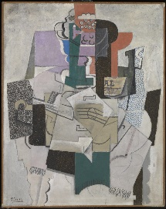  Pablo Picasso-Bowl of Fruit, Violin and Bottle 1914  Picasso was born in Malaga in Spain in 1881, but in 1904 when he was 23 he moved to Paris. Picasso became friends with lots of artists and writers, like Georges Braque who he invented cubism with; and a writer called Gertrude Stein who collected art wrote a cubist book.  Pablo Picasso is one of the most famous artists of the twentieth-century. Even as a child he was better at drawing than many adults. He could draw and paint just about anything, and in any style. He liked to experiment and try out new ideas, which is important if you are an artist, because the world is always changing. Picasso helped us see the world in new ways. | 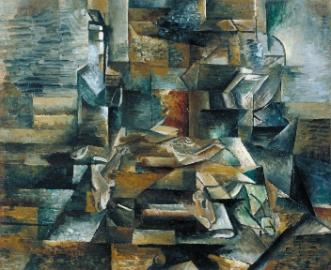  Georges Braques- Bottle and Fishes 1910-1912  Georges Braque was born on May 13, 1882, in Argenteuil, France, a riverside village near Paris. His father and grandfather were professional painter-decorators and Sunday landscape painters.  A large Cézanne retrospective in 1907 inspired Braque to take a totally new approach to landscape, based on structure, mass, and form. In 1908, when the first paintings in this new style were shown, an indignant critic noted that Braque had reduced nature to “geometric outlines, to cubes.” This remark was the origin of the term “cubism.” Working with his friend Pablo Picasso, he explored all the possibilities of cubism. From 1909 to 1914 the two artists collaborated so closely that their works were often difficult to distinguish.
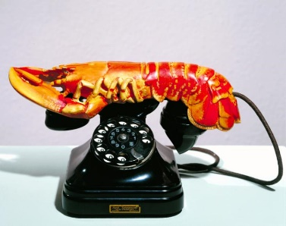  Salvador Dali- Lobster Telephone  Salvador Dalí made paintings, sculptures and films about the dreams he had. He painted melting clocks and floating eyes, clouds that look like faces and rocks that look like bodies.  Dalí was born in 1904 in Figueres, Spain which is near the Pyrenees Mountains. Surrounded by this landscape as he was growing up, Dalí often included the scenery he saw as a boy in his paintings.  Salvador Dalí went to Paris after leaving art school, which was where he met the surrealists. The surrealists appealed to his wild sense of humour, they invented surrealist games and enjoyed putting different objects together to make something playful and disturbing at the same time. Here is Dalí's version of a surrealist sculpture. | 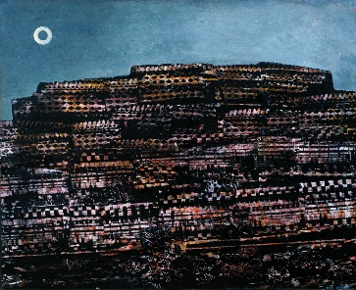  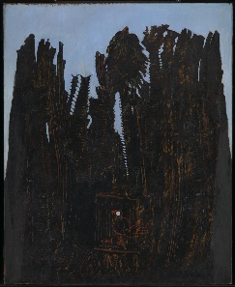  Max Ernst-  Forest and Dove 1927 (left) and The Entire City 1934  Max Ernst (2 April 1891 – 1 April 1976) was a German painter, sculptor, graphic artist, and poet.  A prolific artist, Ernst was a primary pioneer of the Dada movement and surrealism. He had no formal artistic training, but his experimental attitude toward the making of art resulted in his invention of frottage and grattage.  Both these paintings use a combination of these two techniques created using wood, paint and the backbone of a fish.

