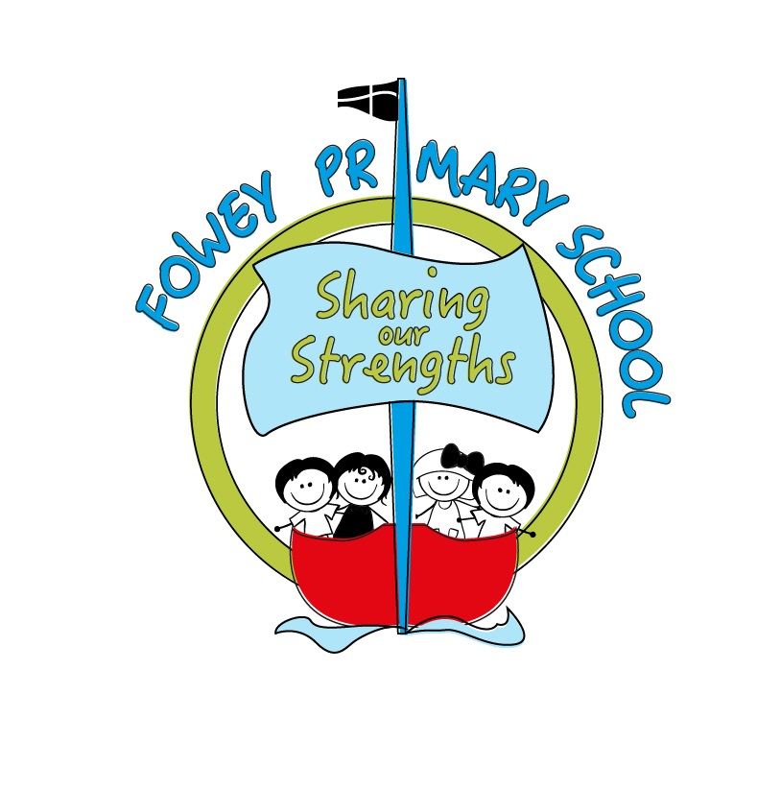
FOWEY PRIMARY SCHOOL- Behaviour Policy and Procedures September 2020

This policy and procedure has been adapted in light of current requirements that schools maintain strict bubble systems during the Covid-19 Pandemic. It is likely that these amendments will be in place for the academic year 2020-2021. When the bubble system is no longer in place these procedures will be formally reviewed.

Our Ethos and Philosophy

At Fowey Primary School we expect everyone to model our values at all times; Collaboration, Aspiration, Respect and Empathy. Our expectation of exemplary behaviour is key to this.

We believe that children need to behave well to get the best from their learning. At the moment, good behaviour and following staff expectations quickly and calmly is key to keeping everyone safe.

We have high expectations of our children. We know that children are learning the social and emotional skills they need to be successful adults and so will take all opportunities to teach children about the best possible choices. We know that we all make mistakes sometimes, which help us learn.

We expect all adults in our school community to teach that we all have choices about our behaviour; we can make great choices or poor choices. When children have made poor choices there will be a consequence, which is designed to help that child reflect on their choice and the importance of making different choices in future. In the current climate, these consequences will be swiftly applied should any child behave in a way which puts themselves or others at risk. This includes leaving the bubble or repeatedly refusing to follow adult instructions (e.g. hand washing and using appropriate outdoor play spaces).

Children who have made great choices or have shown exceptional effort are rewarded, using our system of recognitions.

Exemplary behaviour is a partnership and we expect all families to form a key part of our approach and to support staff and their decisions. All new parents at our school will be asked to sign a copy of our Home School Agreement to reflect this. This behaviour amendment will be circulated to all parents who will be asked to sign a letter acknowledging they have received it and agree to support the school in implementing these expectations.

Our Golden Rules

- We are gentle (We don’t hurt others)
- We are kind and helpful (We don’t hurt anyone’s feelings)
- We listen (We don’t interrupt)
- We are honest (We don’t cover up the truth)
- We work hard (We don’t waste out own or others’ time)
- We look after property (We don’t waste or damage things)
- We stay in our bubbles (We don’t ever wander off or go in other groups’ spaces)
- We try to stay apart from other people (We don’t go close to them unless an adult says we can)
- We wash our hands and catch sneezes or coughs in a tissue.

Our Recognitions

We recognise children’s great choices or exemplary effort by:

Giving specific praise
Headteacher’s Award certificates, presented online in Friday Zoom assembly
Stickers
House Points (collected on the House Point chart in class and shared in Zoom assembly)
Sending letters and postcards home
Displaying work on the Aspiration wall
Choosing children to be the Class Captain for the day
Golden Time (earned during the week by each class and celebrated on a Friday together)
Golden table- for the class showing the best behaviour in the dining hall including choosing the music

Our Consequences

All incidents resulting in a consequence, beyond a reminder, are recorded using CPOMS (our secure, online safeguarding and behaviour system). Any incident of a discriminatory nature (e.g. racist or homophobic language) is also recorded.

Consequences are led by the child’s class teacher and are designed to help that child learn from their choice. In the current climate it is more important than ever that children respond positively to adult instructions. We have no choice but to take robust action should children refuse to maintain our Golden Rules at this time, particularly when remaining within their designated spaces and being safe.

Stage One | Reminder with explanation.
Stage Two | Teacher sees child at playtime to discuss incident before going out to play (time is determined by nature of incident) /completion of work before going out to play.  If outside or in the dining room- child is asked to wait to the side until an adult is available to talk to them about their choices.
Stage Three | Headteacher or Senior Member of Staff intervention- phone call or e-mail home.
Stage Four | Phone call home to ask parent to collect child for the rest of the day- fixed term exclusion.
Children who are repeatedly not meeting our expectations will have an individual risk assessment to map out how they can safely be at school at this time. This may include additional interventions and support (e.g. referrals to other agencies, sessions with our TiS worker or a part-time timetable, with the agreement of parents).

At the moment, we cannot use our nurture room as we have previously, as children must remain in their bubbles. This means that children must be able to safely remain within their main classroom.

Permanent Exclusions are used at Fowey as a very last resort where a child has made a choice which has resulted in themselves or someone else being unsafe. We expect children to follow the instructions of staff and where children are repeatedly non-compliant, this may also result in an exclusion. We follow the statutory DFE guidance on Exclusions, which can be found here https://www.gov.uk/government/publications/school-exclusion

Break and Lunch Times- Supplementary Golden Rules

Playground Golden Rules

• We are gentle when we play.
• We are kind and helpful towards others.
• We respect everyone’s games.
• We look after the playground and our equipment.
• We listen to and keep the playground safety rules.
• We are honest with everyone.
• We make sure no-one is left on their own.

Dining Room Golden Rules

- We wait calmly
- We walk carefully
- We speak quietly
- We keep our table and the floor clean
- We are polite and friendly to everyone
- We use good table manners

