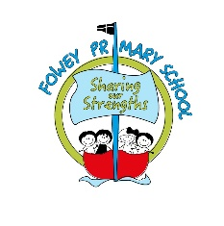
Summary Conclusions from our RSE Consultation- July 2021
Children remember being taught a good amount of PSHE content including being safe (both online and in the real world) and about their own mental health. Children have a good understanding of what mental health is and how it is important. They also recall learning about racial difference and different families. Children felt confident to ask questions about other things they want to learn.
There is, however, currently a disparity between what children feel is most important and what most children remember learning. Children believe it is most important to learn about how babies are made, how their bodies change as they grow up and about being confident in their own body but less than 50% of children could recall being taught these things at school. Children’s drawings also showed that they don’t have a good understanding of puberty and how their body might change.
Children have questions about people who are different to their family and do have some awareness of terms such as transgender or LGBTQ+. They ask questions to parents and staff about these issues.
There is a common concern among parents and children about body image- with children equating being ‘grown up’ with being attractive and wearing make-up. Sometimes children in our school think that being thin will ensure you are happy.
Most children are excited about growing up but some do feel worried about this.
The vast majority of parents want their children to be taught a broad curriculum which includes sex education elements as well as relationships. There are some parents who feel that their child is too young for this and there are some parents who would want to remove their child from optional sex education lessons (which is, of course, their right).
While parents and staff think it’s important for children to know the correct terms to describe people’s bodies, no children used these terms in any of our pupil consultation exercises. We need to do more to make sure all children are familiar and confident with these terms.
A number of parents were very keen for us to include wider issues into our PSHE teaching, including the dangers of online gaming and mobile phones (especially the taking and sharing of images), airbrushing and body image.
Most parents at our school say they already feel very confident to talk to their child about these things.

