The Arts 3: How is painting outside different?
Impressionism and Post Impressionism
Key Vocabulary |  | What should I already know?  Artworks and craft by four famous artists and four Cornish artists.  Sculpting, manipulating and moulding malleables including clay, plasticine and play dough including with internal frames and structures.  Study of our local area in Geography/ Science 2  Printing using pre-made stamps and potato printing on fabric  Weaving on a CD.  Music of the 1950’s and Cornish sea shanty singing.  Drumming (Djembe and Samba)  Vocabulary from Art 1 and Art 2
impressionism
abstract impressionism
post impressionism
oil (paint)
acrylic (paint)
brush strokes
landscape
Impressionism (1874-1886)  Impressionism developed in France in the nineteenth century and is based on the practice of painting out of doors and spontaneously ‘on the spot’ rather than in a studio from sketches. Main impressionist subjects were landscapes and scenes of everyday life  Impressionist artists were not trying to paint a reflection of real life, but an ‘impression’ of what the person, light, atmosphere, object or landscape looked like to them. They tried to capture the movement and life of what they saw and show it to us as if it were happening before our eyes.  Before impressionism, landscapes in art were often imaginary, perfect landscapes painted in the studio. The impressionists changed all that. They painted outdoors.  As they were outside, they looked at how light and colour changed the scenes. They often painted thickly and used quick (and quite messy) brush strokes. In most of the paintings before impressionism you can't really see the brushstrokes at all. |  |  | Post Impressionism (1886- 1905)  Post-impressionism describes the changes in impressionism from about 1886, the date of last Impressionist group show in Paris  Post-Impressionists extended Impressionism by rejecting its limitations: they continued using vivid colours, often thick application of paint, and real-life subject matter, but were more inclined to emphasize geometric forms, distort form for expressive effect, and use unnatural or arbitrary colour.
Sewing Techniques and Textiles  Weaving on a cardboard loom https://www.youtube.com/watch?v=AWLIy-Um7_0  Cross stitch using binka  Finger Knitting  https://youtu.be/jCcD4LOSr7U  Friendship Bracelets  https://www.tate.org.uk/kids/make/cut-paste/make-friendship-bracelet |  | Key Experiences  See an Orchestra perform (Plymouth, Bristol or Truro)  Painting outdoors from scenes in our local area
Music
Instrumental Teaching-  Y2- Guitar  Y3- Violin  Including musical notation on the attached rhythm chart. |  | Exploration-  Late Romantic Music (c. 1860 - c. 1920)  The Nutcracker by Tchaikovsky (six lesson sequence)  http://downloads.bbc.co.uk/tv/tenpieces/lessonplans/Tchaikovsky_lesson_plan_Primary.pdf

Key Artists and their work
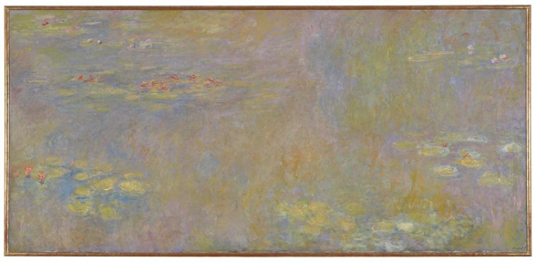  Claude Monet- Water Lilies (after 1916)  Monet was born in Paris in 1840 and as a child he showed great talent as an artist. In 1872 he painted a picture of a harbour using very loose brushstrokes. He called the picture Impression, Sunrise and exhibited it along with paintings by his friends who also painted 'en plein air'. The artists became known as the impressionists after the title of Monet's painting.  This picture of water lilies was part of a series Monet painted of his water garden at his house at Giverny. They are the most celebrated paintings of Monet's career.  Today we call these pictures abstract-impressionist paintings, because the surface of the pond fills the entire canvas with light and colour and the picture looks almost abstract. | 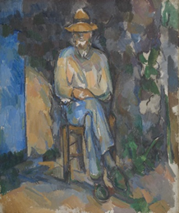  Paul Cezanne- The Gardener Vallier 1906  Paul Cézanne was a French artist and Post-Impressionist painter whose work was key in the shift from impressionist to post-impressionist art.  Cézanne's often repetitive, exploratory brushstrokes are highly characteristic and clearly recognizable. He used planes of colour and small brushstrokes that build up to form complex fields. The paintings convey Cézanne's intense study of his subjects.  Vallier was the gardener and odd-job man at Cézanne's house near Aix-en-Provence. This is one of six portraits of him, and was probably painted in the summer and autumn of 1906, not long before Cézanne's death in October that year.
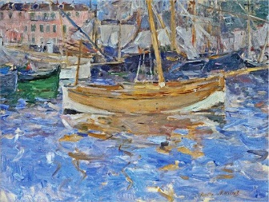  Berthe Morisot- The Harbour at Nice  Berthe Morisot was born in 1841 in Paris, France. Her family was wealthy and when she was growing up her parents encouraged her and her sister Edma to take art lessons. She grew up to become the only woman in the first show of impressionist art in 1877.  Because of people’s attitude towards women at the time, she was not meant to go out alone and paint scenes in bars and cafes, or even in parks.  When Morisot became a professional artist she would hide her paintings and materials away when people came to visit. Even though she sold a lot of paintings and was successful in her lifetime, it was still frowned upon for a woman to be a painter. | 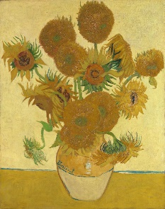  Vincent Van Gogh- Sunflowers 1888  Vincent van Gogh is one of the world’s most famous painters. He was born in the Netherlands, but travelled across Europe. He went to France, Belgium and England.  Van Gogh was interested in painters who were painting everyday life.  When he was 27, he decided to become an artist. Up until then, he had been a teacher, a shop assistant and had dreams of working for the Church. All of these experiences inspired his art.  This painting, Sunflowers, is very famous. He painted it for the room in the yellow house he was renting in Arles, France.

