Science Unit Five: Electricity (six week mini-project)

Carne and Readymoney Autumn 2020
What should I already know?  Electricity is a form of energy that can be carried by wires and is used for heating and lighting, and to provide power for devices.  Sources of light and sound may need electricity to work.  Magnets, magnetism and forces as pushes and pulls. | Key Knowledge  Electricity is generated using energy from  natural sources such as the sun, oil, water and  wind.  These can also be called fuel sources.  Some appliances use batteries and some use  mains electricity.  Batteries come in different sizes depending on  how much power is needed.  A complete circuit is a loop that allows electrical current to flow through wires.  A circuit contains a battery (cell), wires and an  appliance that requires electricity to work (such  as a bulb, motor or buzzer).  The electrical current flows through the wires  from the battery (cell) to the bulb, motor or  buzzer.  A switch can break or reconnect a circuit as it controls the flow of the electrical current around the circuit. When the switch is off, the current cannot flow. This is not the same as an incomplete circuit.  When objects are placed in the circuits, they may  or may not allow electricity to pass through.  Objects that are made from materials that allow  electricity to pass through a create a complete  circuit are called electrical conductors.  Objects that are made from materials that do  not allow electricity to pass through and do not  complete a circuit are called electrical insulators.  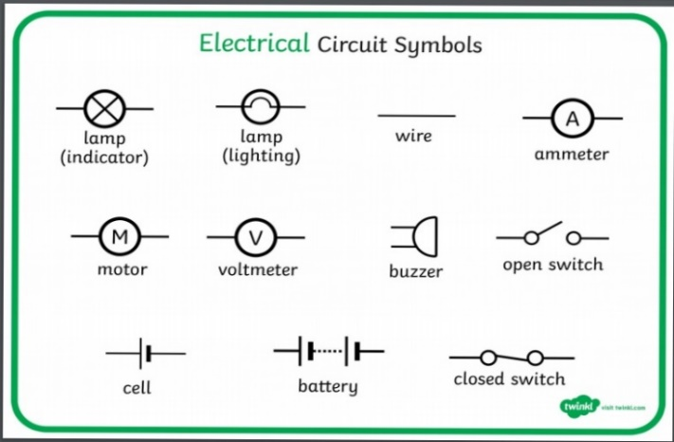
Key Vocabulary
Key Term | Definition
appliances | a device or machine in your home that you use to do a job such as cleaning or cooking. Appliances are often electrical.
battery | small devices that provide the power for electrical items such as torches
bulb | the glass part of an electric lamp, which gives out light when electricity passes through it.
buzzer | an electrical device that is used to make a buzzing sound
cell | a synonym for battery
circuit | a complete route which an electric current can  flow around
component | the parts that something is made of
conductor | a substance that heat or electricity can pass  through or along
current | a flow of electricity through a wire or circuit  device an object that has been invented for a  particular purpose
electricity | a form of energy that can be carried by wires  and in used for heating and lighting, and to  provide power for devices
energy | the power from sources such as electricity that  makes machines work or provides heat
fuel | a substance such as coal, oil, or petrol that is  burned to provide heat or power
generate | cause it to begin and develop
insulator | a non-conductor of electricity or heat
mains | where the supply of water, electricity, or gas enters a building
motor | a device that uses electricity or fuel to produce  movement
power | Power is energy, especially electricity, that is obtained in large quantities from a fuel source and used to operate lights, heating and machinery
source | where something comes from
switch | a small control for an electrical device which you use to turn the device on or off
wires | a long thin piece of metal that is used to fasten things or to carry electric current

Key Experiences
making a circuit using a bulb and a buzzer
drawing a simple circuit
testing insulators and conductors
visit to Suez waste recycling and energy centre at St Dennis

