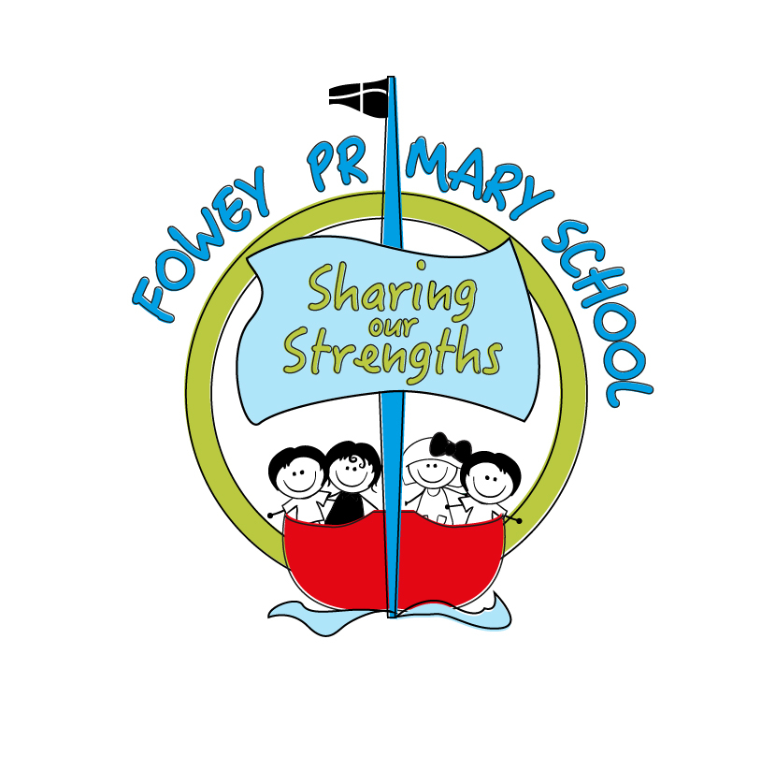
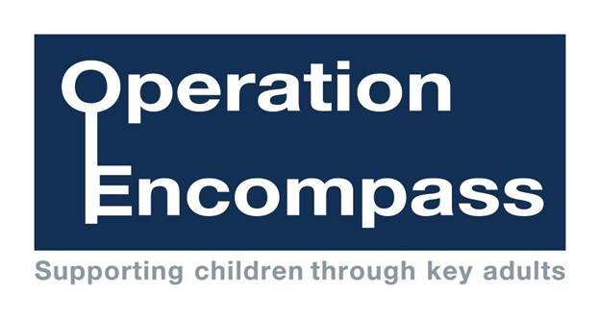

10th October 2017

Dear Parent/Carer,

All schools in Cornwall will be working together from the 31st October to keep children safe through a new project called Operation Encompass. This project is already successfully running in 22 police areas across the UK. It is an information sharing project between schools and the local police force.

Operation Encompass staff from Devon and Cornwall Police will inform schools, prior to the start of the next school day, when a child or young person has exposed to, or involved in, any domestic abuse incident which the police have attended.

The aim of this is to ensure that the school is able to offer appropriate support to children when they come to school and to allow us to prepare necessary staff to respond to different children’s needs. For example, if we know a child has experienced an issue at home the night before, we may adjust the staffing levels in a certain class to ensure that someone is available to speak with that child, should they wish to.

There will be two trained key adults in school, myself and Mrs Barnes, who will receive a call from the police, should this be needed. We would encourage parents who have had a domestic incident to come in and talk with us, as so many parents currently do, so that we are all able to work together in the best interests of the children. Mrs Barnes and myself have been trained to allow us to liaise with the police and to use the information that has been shared, in confidence, while ensuring that the school is able to make provision for possible difficulties experienced by children, or their families, who have been involved in, or exposed to, a domestic abuse incident.

We are keen to offer the best support possible to all our pupils and we believe this will be extremely beneficial for all those involved.

Please come and talk to us if you have any questions about Operation Encompass.

Signed,

Kate Sicolo, Headteacher

