Humanities Two: Where would the wind take me?

What should I already know?  Monarchy and notable kings/queens including Elizabeth I  UK history including London as capital city and countries of the UK |  | Key Experiences  Visit to The Box museum in Plymouth with two workshops- The Mayflower and The Mayflower Art  Overnight Sleepover visit to National Maritime Museum in Falmouth with workshops (Francis Drake and Cornish Explorers)  Boat trip/ sailing session
Key Vocabulary
Key Term | Definition
slave
slave trader
armada
fleet
valley
Argentina
country
continent
Ocean
island

Contrasting Locations: Fowey, UK and Ushuaia, Argentina
 | Fowey |  | Ushuaia
Population | 2315 |  | 59,956
Meaning of the Name | The word Fowey means ‘beech trees’ |  | The word Ushuaia comes from the Yaghan language: ush and waia ("bay" or "cove") and means "deep bay"
When did people first settle here? | People have lived in Fowey since at least 600 AD. The estuary of the River Fowey forms a natural harbour which enabled the town to become an important trading centre. Privateers also made use of the sheltered harbourage.  The Lostwithiel and Fowey Railway brought China clay here for export.  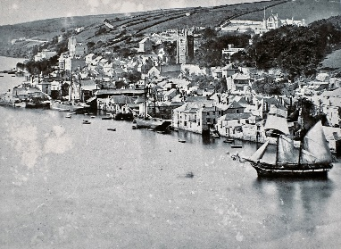 |  | People have lived in Ushuaia for at least 10,000 years. The first people to live here were called the Yaghan people.  The Yaghan were traditionally nomads and hunter-gatherers. They traveled by canoes between islands to collect food: the men hunted sea lions, while the women dove to collect shellfish.  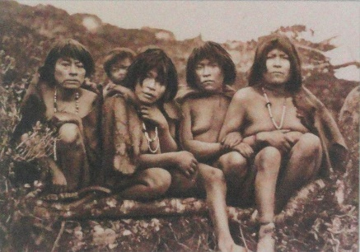
Weather | The hottest month in Fowey is August, with the highest temperature recorded 26˚C |  | The hottest month in Ushuaia is December, with the highest temperature recorded 19 ˚C
Important Facts | It lies at the end of the Saints' Way and has ferries across the river to Polruan (foot) and Bodinnick (vehicle).  Fowey has been the inspiration for many authors, including Sir Arthur Quiller-Couch ('Q'), Daphne du Maurier and Kenneth Grahame. |  | Ushuaia is the most Southerly city in the world.  It is pronounced "oo -swy-ah" by Argentines.  Ushuaia is not connected to mainland Argentina. The city is on the island of Tierra del Fuego, which is divided between Chile and Argentina. To reach the city by land, you have to cross into Chile and take a ferry across to the island.

Significant People in History

Francis Drake
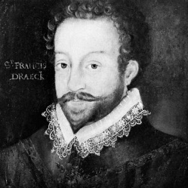
The navigator Sir Francis Drake helped to build up England’s power during the reign of Queen Elizabeth I. He opened the Pacific Ocean to English ships. He also helped defeat the Armada, the fleet (group of ships) that Spain sent to conquer England.

Francis Drake was born in about 1540. At about age 13 he first worked as a sailor. In his early 20s he joined a slave-trading fleet. Off the coast of Mexico, the Spanish attacked the fleet. Drake disliked the Spanish from that time on.

In 1572 Drake attacked a Spanish settlement in Panama and took much treasure. Then he marched across Panama and saw the Pacific Ocean. Spain controlled travel in the Pacific. Drake wanted English ships to be able to use the ocean.

In 1577 Queen Elizabeth sent Drake on an around-the-world voyage. Drake left England with five ships, but only his ship completed the trip. He passed through the Strait of Magellan, at the southern tip of South America, and into the Pacific. He then sailed up the coasts of South and North America. In 1579 he crossed the Pacific and Indian oceans. In 1580 he returned to England. His ship was loaded with treasure. Queen Elizabeth rewarded Drake by making him a knight.

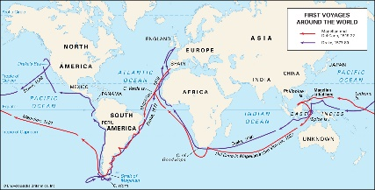
In 1586 King Philip II of Spain gathered a fleet of warships—called the Armada—to invade England. In 1587 Drake destroyed many of the ships in a raid on the Spanish port of Cádiz. When the Armada invaded in 1588, Drake was a leader in driving it back. He became England’s hero.

Drake’s last voyages were less successful. In January 1596, while fighting the Spanish in the West Indies, he became ill and died.

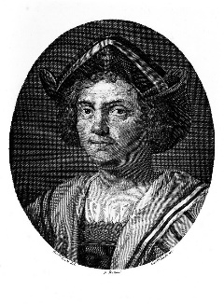
Christopher Columbus

Known as 'the man who discovered America', Columbus was in fact trying to find a westward sea passage to the Orient when he landed in the New World in 1492. There were already 100 million people living in the America, which is roughly the same as the number of people living in Europe at that time, but the people in Europe didn’t know this.

People in Europe wanted to find a new route to the Indies, which was the name they gave to the Far East. Since the fall of Constantinople in 1453 the old Silk Route, along which silk, spices and other luxury items had been traded for centuries, had become difficult and costly to use.

Columbus hoped to find a new route east. He believed he could do this by sailing west. When he landed in the Americas he was convinced he was actually in the East Indies and so called the native people Indians.

Columbus left Palos in Spain on 3 August 1492 with ninety men and three small ships, the Nina, the Pinta and the Santa Maria. Their first stop was the Canary Islands where they collected supplies before settling out across the Atlantic on 6 September of the same year. Land was first sighted on 11 October 1492 and on 12 October Columbus landed on an island in the Bahamas which he called San Salvador.
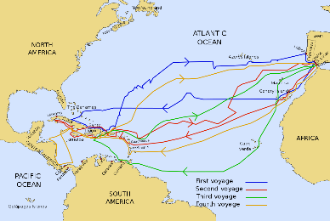
The second voyage on 24 September 1493 was made by 17 boats with 1200 men. The aim of the voyage was to colonise the new discoveries and convert the native people to Christianity. Columbus then made four voyages to the New World. He explored the Greater and Lesser Antilles, Venezuela and central America.

The native peoples of the Americas were treated very cruelly by Columbus and his men who exploited and enslaved them.

It was Amerigo Vespucci who realised that a new continent had been discovered, so the Americas were named after him rather than Columbus.

