The Arts 2: Who was Barbara Hepworth? Why do so many artists make Cornwall their home?

Key Vocabulary |  | What should I already know?  How to join simple materials together using glue, tape and paint.  Simple painting and blending techniques.  How to shape simple forms using plasticine and playdoh by moulding, squashing, cutting and pressing.  In Year One- Art 1  Four well known artists and their work (Miro, Da Vinci, Matisse, Kandinsky and Pollock)
Form | the visible shape of something
Media | the materials used to create a work of art.
Shape: | the outline of something
Sculpture | the art of creating 3D forms
Mixed Media | a variety of media used in a work of art
Interpretation | to explain the meaning of something
Abstract | modern art which does not represent images of our everyday world
Pattern | a repeated design
Design | a sketch, model or plan of something made or to be made
Texture | what things are made of and how they feel
Sewing Techniques and Textiles  Running stitch- https://youtu.be/i1-B01FB56s |  | Key Experiences  Visit to Tate St Ives  Visit to Hepworth Sculpture Garden  Visit to Leach Pottery with workshop  Work alongside local artist (at school) to create shared artwork  Visit by Cornish singing group- sea shanties/ Male voice choir
Music
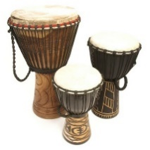  Instrumental Teaching-  EYFS- Djembe drumming  Y1- Samba drumming  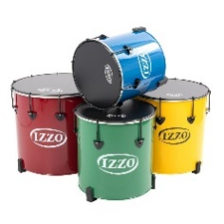 |  | Vocal Teaching-  Sea shanties to include South Australia, Blow the Man Down, Spanish Ladies and Cornwall, My Home (Harry Glasson)

The Arts 2: Who was Barbara Hepworth? Why do so many artists make Cornwall their home?

Key Artists and their work
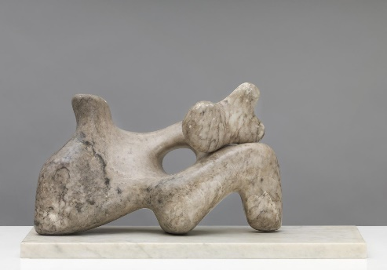  Barbara Hepworth- Mother and Child 1934 | 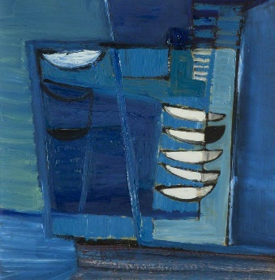  Sir Terry Frost- Walk along the Quay 1948-1949
Mother and Child 1934 is a small abstract stone sculpture by the British artist Barbara Hepworth. She made this sculpture while she was pregnant.  The larger shape represents the reclining figure of the mother, and the smaller shape that rests on top of it a child held in her embrace  It is made of alabaster with a marble base.  Mother and Child is a direct carving. This means that it was carved directly into a piece of alabaster. Through this technique, artists emphasised the properties of the materials, and the marble, stone and wood that they used was rubbed and polished in order to enhance its natural texture, colours and markings. | Walk along the Quay is an oil painting.  Sir Terry Frost said ‘ Walk Along the Quay came from a true walk, a regular morning stroll and the constant movement always ... intrigued me ... Things were happening to my right and beneath – my feet felt and saw all the shapes of boats tied up and either preparing to go out or unloading. The strange feeling of looking on top of boats at high tide and at the same boats tied up and resting on their support posts when the tide’s out […] So after all this I had no problem in finding out how to paint Walk Along the Quay ...I managed to paint up the canvas or along the canvas, like I walked along the quay, in fact I just walked up the canvas with paint.
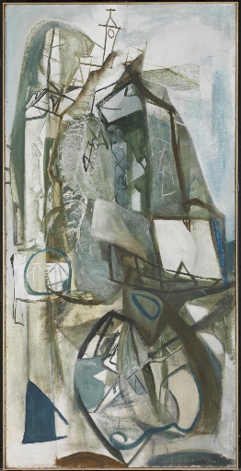  Peter Lanyon- Porthleven 1951 | 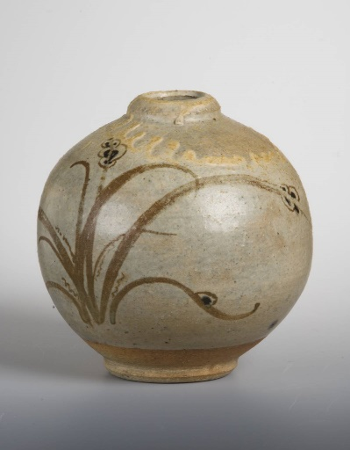  Bernard Leach- Spherical Vase 1927
Porthleven is an oil painting which shows a village in West Cornwall. Lanyon liked to show a place from different positions and combine these different views with what he knew about the geology, history, culture and myths of a place into one artwork.  Here he shows the fishing history of the village, the clock tower and harbours. | The 1920s saw a revival in traditional crafts.  The potter Bernard Leach mixed a revival of pre-industrial English designs with similarly traditional styles from Japan, where he had studied.

