The Arts 5: Can Art change the world?
BAME Contemporary Artists
Key Vocabulary |  | What should I already know?  Artworks and craft by four famous artists and four Cornish artists, development of Art through impressionism and post-impressionism.  The work of impressionist/post-impressionist/ cubist and surrealist artists.  Weaving on a CD and a cardboard loom. Study of Anni Albers. Finger knitting. Running stitch and tie dye.  Music of the 1950’s, Cornish sea shanty singing, Late Romantic music study (Tchaikovsky’s Nutcracker) and Spanish Music Study.  Rhythm notation and musical vocabulary for pitch, speed and volume.  Drumming (Djembe and Samba) and 2 string instruments  Vocabulary from Art 1-Art 4.
exile
empire
colonialism
protest
installation
guerilla
Sewing Techniques and Textiles  Applique and finishing decorations  Knitting  Kente cloth weaving (initially with paper leading to weaving on a wooden loom)  Resist dying including Batik |  | Key Experiences  Visit to Tate Modern/ Tate Britain as part of London residential  Visit to Anish Kapoor Olympic Park sculptures during London Residential  Gospel choir performance
Music

Instrumental Teaching- woodwind and brass  Y4/Y5- Cornet/ Trumpet  Y5/Y6- Clarinet |  | Vocalisation-  Close study of African-American Spirituals including Swing Lo, Sweet Chariot, Go Down Moses and No More Auction Block for Me (Paul Robeson).  Compare and contrast with Cornish tradition of sea shanty singing.

Key Artists and their work
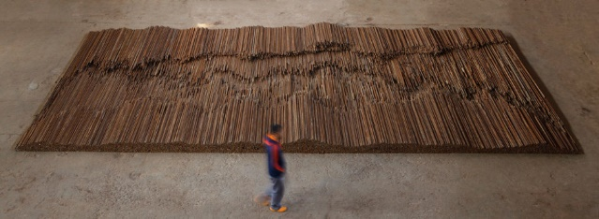  Ai Wei-Wei- Straight 2008-2012  Ai Weiwei is a Chinese contemporary artist and activist. Ai grew up in the far north-west of China, where he lived under harsh conditions due to his father's exile.  As an activist, he has been openly critical of the Chinese Government's stance on democracy and human rights.  He investigated government corruption and cover-ups, in particular the Sichuan schools corruption scandal following the collapse of "tofu-dreg schools" in the 2008 Sichuan earthquake. This work ‘Straight’ was created as a poignant response to this earthquake. Poorly built schools in the Sichuan province – held up by steel rods which twisted and mangled in the quake – were devastated, leaving thousands of students dead.  These rods (which Ai had labourers straighten by hand) make up the 90-ton floor-based sculpture, that is laid out in broken undulations recalling fault lines.  In 2011, Ai Weiwei was arrested at Beijing Capital International Airport on 3 April, for "economic crimes". He was detained for 81 days without charge. After being allowed to leave China in 2015, he has lived in Berlin, Germany, and, since 2019, in Cambridge, UK, with his family, working and traveling internationally. | 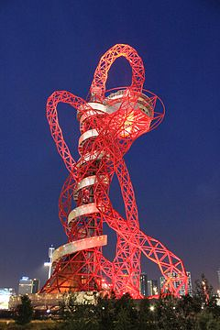  Anish Kapoor- Orbit 2012  Sir Anish Kapoor (born 12 March 1954) is a British Indian sculptor specializing in installation art and conceptual art. Born in Mumbai, Kapoor has lived and worked in London since the early 1970s when he moved to study art.  His notable public sculptures include Cloud Gate (2006, colloquially known as "the Bean") in Chicago's Millennium Park; Sky Mirror, exhibited at the Rockefeller Center in New York City in 2006 and Kensington Gardens in London in 2010; Temenos, at Middlehaven, Middlesbrough; Leviathan, at the Grand Palais in Paris in 2011; and ArcelorMittal Orbit, commissioned as a permanent artwork for London's Olympic Park and completed in 2012. In 2017 Kapoor designed the statuette for the 2018 Brit Awards.  http://anishkapoor.com/332/orbit-2
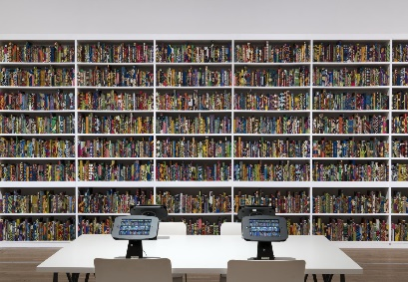  Yinka Shonibare- The British Library 2014  Yinka Shonibare (born 1962) is a British-Nigerian artist living in the United Kingdom. His work explores cultural identity, colonialism and post-colonialism within the contemporary context of globalisation. A hallmark of his art is the brightly coloured Dutch batik wax fabric he uses. Because he has a physical disability that paralyses one side of his body, Shonibare uses assistants to make works under his direction.  The British Library 2014 is an installation of 6,328 hardback books individually covered in colourful ‘Dutch wax print’ fabric and arranged on rows of shelving. Names are printed in gold leaf on the spines of 2,700 of the books, the majority of which are of first- or second-generation immigrants to Britain, both celebrated and lesser-known, who have made significant contributions to British culture and history.  https://thebritishlibraryinstallation.com/ | 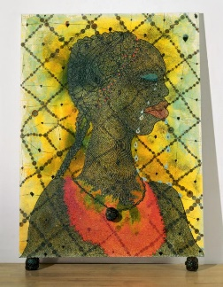  Chris Ofili- No Woman No Cry 1998  Christopher Ofili, (born 10 October 1968) is a British Turner Prize-winning painter who is best known for his paintings incorporating elephant dung. He was one of the Young British Artists. Since 2005, Ofili has been living and working in Trinidad and Tobago, where he currently resides in Port of Spain. He also lives and works in London and Brooklyn.  Ofili has utilized resin, beads, oil paint, glitter, lumps of elephant dung, cut-outs from porn magazines as painting elements. His work has been classified as "punk art."No Woman No Cry is a tribute to the London teenager Stephen Lawrence who was murdered in a racially motivated attack in 1993. A public inquiry into the murder investigation concluded that the Metropolitan police force was institutionally racist. In each of the tears shed by the woman in the painting is a collaged image of Stephen Lawrence’s face, while the words ‘R.I.P. Stephen Lawrence’ are just discernible beneath the layers of paint. As well as this specific reference, the artist intended the painting to be read as a universal portrayal of melancholy and grief.
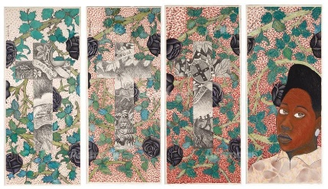  Sonia Boyce-  Lay back keep quiet and think of what made Britain so great 1986  Sonia Dawn Boyce, (born 1962), is a British Afro-Caribbean artist, living and working in London. She is a Professor of Black Art and Design at University of the Arts London. Boyce's work involves a variety of media, such as drawing, print, photography, video, and sound. Her art explores the interstices between sound and memory, the dynamics of space, and incorporating the spectator.  In February 2020 Boyce was selected by the British Council to represent Britain at the Venice Biennale 2021. She will be the first black woman to do so.  Of this piece, Boyce said ‘I was really into William Morris wallpapers and then there was a wallpaper that was designed to commemorate Queen Victoria’s 50th anniversary and of, really, the empire and in this wallpaper the various continents that the British Empire ruled over’. I used that as a kind of background to kind of talk about both the church, the church’s relationship in terms of empire, the question about colonialism’. | 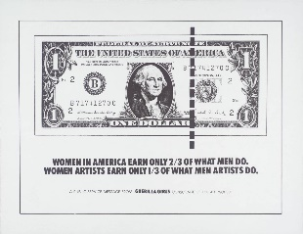  Guerilla Girls-  Women In America Earn Only 2/3 Of What Men Do 1985  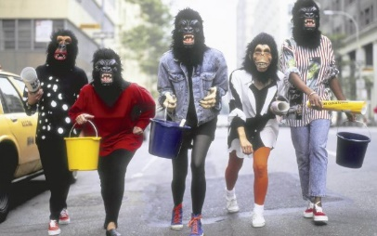  Guerrilla Girls is an anonymous group of feminist, female artists devoted to fighting sexism and racism within the art world. The group formed in New York City in 1985 with the mission of bringing gender and racial inequality into focus within the greater arts community. The group employs culture jamming in the form of posters, books, billboards, and public appearances to expose discrimination and corruption.  To remain anonymous, members don gorilla masks and use pseudonyms that refer to deceased female artists. According to GG1, identities are concealed because issues matter more than individual identities, "[M]ainly, we wanted the focus to be on the issues, not on our personalities or our own work."

