Humanities Four: Could ancient civilisations exist in the modern world?

What should I already know?  History is the study of things that have happened before now  Significant events in the past (e.g. Great Fire of London)  Where key countries are around the world and how their cultures are different  The difference between countries and continents. | Key Experiences  Visit to Truro Museum.  Loan Museum box and artefacts from Truro Museum following visit.  Visit to Carn Euny and Chysauster  Build a Maya pyramid  Create your own pictorial writing system
Key Vocabulary  Key Term Definition  Indus Valley The Indus Valley was home to one of the world's first large civilisations. It began nearly 5,000 years ago in an area of modern-day Pakistan and Northern India  Stone Age (1500BC – 2500BC) A pre-historic period where weapons and tools were made of stone or of organic material such as wood or bone  Bronze Age (3000BC-800BC) A period of history characterised by the use of bronze  Iron Age (3000BC – AD43) Followed Bronze Age and Iron Age where many people across Europe, Aria and parts of Africa began making things out of bronze  BC Before Christ  AD Anno domini – which means in the year of our lord  Fogou A man-made underground passage or chamber found in Cornwall  Civilisation The way of life of a particular area  sources A place, person or thing from which something can be found  artefacts An object made by a human that is of cultural or historical interest  chronology Arranging events or dates in order of when they occur  Maya A civilisation  Mesoamerica Another name for “middle America”  hunter-gatherer A human obtaining most or all of food through foraging  Foraging Searching for food and things  Ancient belonging to the very distant past and no longer in existence | Timeline  3300 BC Famers first settle in the Indus Valley. They found cities like Mohenjo-Daro and Harappa.  3200 BC People in the Indus Valley first begin to use a script or sign ‘writing’ system- which no-one has ever deciphered.  2600 BC Ploughs are used; often pulled by Oxen and Buffalo  1800BC The Indus Civlisation begins to decline. This could have been caused by the drying up of the Ghaggar Hakra.  1500 BC The Indus civilisation comes to an end.  1100 BC The first hunter gathers settle along the Pacific Coast and then expand into the central highlands.  800 BC Village farming and trade becomes established throughout the Maya region.  700 BC Maya writing is developed in Mesoamerica  400 BC Earliest solar calendars are carved in stone  300 BC The Maya adapt to include nobles and kings as rulers.  100 BC The first pyramids are built  AD 683 Pakal the Great of Planque dies and is buried in the temple of Inscriptions  AD 800 Sites in the rainforests and tropical lowlands are abandoned while the Northern lowland flourishes  AD 1502 The first European explorers arrive in Maya  AD 1697 Most Maya cities have now been abandoned after the Spanish conquests- The Mayan civilisation is now over- although lots of Maya people still exist in other places they no longer live together in Mayan cities and towns.
Historical Enquiry and Skills
Compare Indus Valley, Maya and Contemporary Britain using a Venn diagram
Describe how Indus Valley and Maya civilisations have impacted modern society
Present what you know about a civilisation using IT skills
Debate the strengths of each civilisation and make a conclusion as to whether each civilisation could exist today
Examine a variety of sources and use these to make inferences about the past
Discuss the validity and reliability of sources
Describe events and historical process in chronological order

Key Knowledge

Indus Valley (3300BC-1500BC)
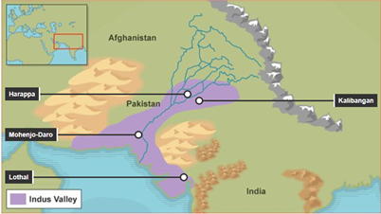
The Indus Valley was home to one of the world's first large civilisations. It began nearly 5,000 years ago in an area of modern-day Pakistan and Northern India.

There were more than 1,400 towns and cities in the Indus Valley. The biggest were Harappa and Mohenjo-Daro. Around 80,000 people lived in these cities.

The names Harappa and Mohenjo-Daro were given to the cities in later times. We do not know what the Indus people called their cities, because nobody has been able to translate their ancient language.

The Indus Valley civilisation left no temples or tombs, like the Pyramids of Egypt. There are also no remains of great statues of kings or gods. Instead the Indus Valley’s cultural legacy is of small and well-crafted art.

While many ancient civilisations focused on worship, it seems that play was very important to the Indus Valley people. They made toys and small figures of people and animals, using metal and clay.
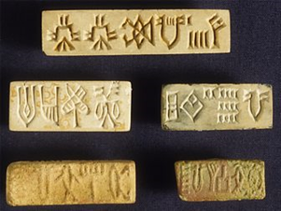
The Indus people wrote on soft clay using pointed sticks or by scratching marks onto stone and metal. They wrote the first line from right to left, the second line from left to right, and so on. Indus Valley writing used at least 400 picture-signs - they were not letters like in our alphabet. But the longest bit of writing found has only 26 characters.

No one knows what language the Indus people spoke, and no one has yet been able to read their writing. Some experts think the Indus language may have been similar to Tamil, which is spoken today by people in southern India and Sri Lanka.

Maya (800BC – current date?)

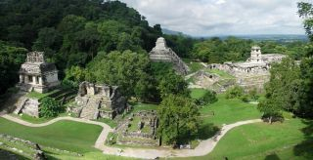
The Maya civilisation began in 'Mesoamerica' (modern day Mexico and part of Central America).

The Mayas built cities like Tikal (which they called 'Yax Mutal') and Palenque. Even though they lived in different cities, ruled by different kings and queens, the Mayas shared common beliefs and traditions.

They were experts at reading the stars and even built cities as maps of the sky! They were also inspired by the creatures of the forest and shared many legends about animals, plants and nature spirits.

The Mayas believed in many gods, each representing a different aspect of life. Communities made regular offerings to them, in the form of animal (and sometimes human) sacrifices.

They believed the Earth had the form of a giant turtle that floated on an endless ocean and that the sky was held up by four mighty gods called Bacabs.

The sky was made up of 13 levels. Those who were sacrificed or who died in battle went to one of the top levels. Those who died of natural causes went to Xibalba, the shadowy underworld, which had nine levels.

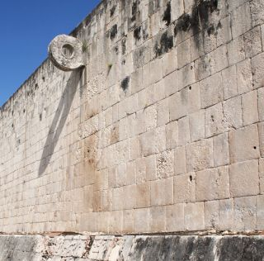
They played a ball game called ulama or Pitz on a T shaped court. Players were not allowed to touch the rubber ball with their hands and had to get it through a stone ring. The captain of the losing team was often sacrificed to the Gods.

Even though the Spanish conquest resulted in centuries of cruelty towards the Maya people, causing their population to decline and them to abandon their cities, over 7 million Mayas still live in central America and Southern Mexico, maintaining some of their traditions. There are 31 Maya languages which are still used today.

