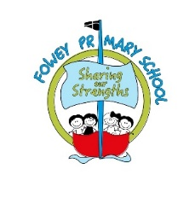
Fowey Primary School PSHE Overview 2021-2022

There are three core themes to our PSHE offer: Health and Wellbeing (green), Relationships (red) and Living in the Wider World (blue)

 | Autumn 1 | Autumn 2 | Spring 1 | Spring 2 | Summer 1 | Summer 2
Lantic | What is the same and different about us? | Who is special to us? | What helps us stay healthy? | What can we do with money? | Who helps to keep us safe? | How can we look after each other and the world?
Cannis | What makes a good friend? | What is bullying? | What jobs do people do? | What helps us to stay safe? | What helps us grow and stay healthy? | How do we recognise our feelings?
Gribben & Coombe | How can I be a good friend? | What keeps us safe? | What are families like? | What makes a community? | Why should we eat well and look after our teeth? | Why should we keep active and sleep well?
Readymoney | What makes up a person’s identity? | What decisions can people make with money? | How can we help in an accident or emergency? | How can friends communicate safely? | How can drugs common to everyday life affect health? | What jobs would we like?
Carne | How can we keep healthy as we grow? |  | How can the media influence people? |  | What will change as we become more independent? How do friendships change as we grow?

