

Fowey Year 4/5 Curriculum Overview Year B

 | Autumn 1 | Autumn 2 |  | Spring 1 |  | Spring 2 |  | Summer 1 | Summer 2
Whole Class Reading | The Boy Who Grew Dragons  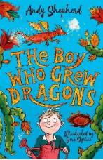 | Charlotte’s Web  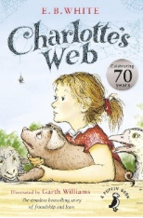 |  | The Girl who Stole and Elephant   |  | Road Dahl – Matilda  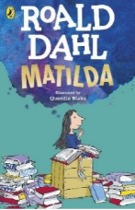 |  | Land of Roar  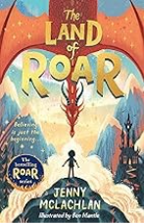 | The Last Firefox  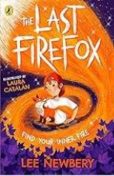
RFP | 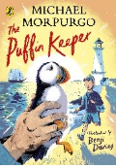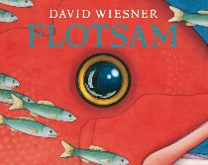 |  |  |  |  |  | 
Writing | PVPG | 5 PVPG Application Unit Guide – Non-chronological report – Bandits, outlaws and pirates (fictional) |  | New CELT Writing Curriculum (being planned for mixed-age classes)
Maths  Year 4 | NUMBER Place value NUMBER Addition and subtraction  NUMBER Multiplication and Division  Measurement - Area |  | Number Multiplication and Division Measurement Length and perimeter Number Fractions A  Measurement Mass & Capacity Number Fractions |  |  |  | Measurement Time Number Decimals Measurement Money Geometry Shape  Geometry Position and Direction Statistics
Maths Year 4 | Place Value (4 weeks)  Addition and Subtraction (3 weeks)  Measurement: Area (1 Week)  Multiplication and Division A (3 weeks) |  | Multiplication and Division B (3 weeks)  Length and Perimeter (2 weeks)  Fractions (4 weeks)  Decimals A (3 weeks) |  |  |  | Shape (2 weeks)  Decimals B (2 weeks)  Money (2 weeks)  Time (2 weeks)  Statistics (1 week)  Position and Direction (2 weeks)  Plus two consolidation weeks
Maths Year 5  *units moved for mixed age | Place Value (3 weeks)  Addition, subtraction (2 weeks)  Multiplication and Division A (3 weeks)  Perimeter and Area (2 weeks)  Volume (1 week) |  | Multiplication and Division B (3 weeks)  Fractions A (4 weeks)  Fractions B (2 weeks)  Decimals and percentages (3 weeks) |  |  |  | Shape (3 weeks)  Decimals (3 weeks)  Converting Units (2 weeks)  Statistics (2 weeks)  Position and Direction (2 weeks)  Negative Numbers (1 week)
Science  Year 5 Units | Properties and changes  of materials | Properties and changes  of materials | Earth and space |  | Living things and their habitats |  | Forces |  | Animals including humans
History  (Year 5 Units) | The round city: Baghdad | Anglo Saxon Britain | Lady of the Mercians |  | Norse Culture |  | Changing Rulers, Changing Worlds |  | Local History
Geography  (Year 5 Units) | Why is California so thirsty? | Oceans | Migration |  | North and South America |  | The Amazon |  | Interconnected Amazon
RE  (Year 5 Units) | Stories of the prophets | Living Muslim Traditions | Living Christian Traditions |  | Christian Sites and Spaces |  | The prince who became the Buddha |  | Buddhist stories and teachings
DT  Year 5 units |  | Electrical Systems: Wobble Bots (Y5) |  |  | Cooking and nutrition: Developing a recipe (Y5) |  |  |  | Textiles: Stuffed toys (Y5)
Art  Year 5 units | Drawing: Depth, emotion and movement (Y5) |  | Painting & mixed media: Portraits (Y5) |  |  |  | Craft and design: architecture (Y5)
Music
PE  Year 5 Units | Invasion Games (Netball) , Gymnastics , | Dodgeball ,  Invasion Games Hockey | Yoga ,  Handball |  | Fitness ,  Net and wall Badminton , |  | Dance ,  Athletics |  | Striking and Fielding (Rounders) ,  OAA
MFL  (Year 5 units) | French monster pets | Space exploration in French | Shopping in France |  | French speaking world |  | Verbs in a French week |  | Meet my French family
PSHE, SRE & Citizenship Year 3 do Year 3 units  Year 4 do Year 4 units. | Being Me in My World | Celebrating Differences | Healthy Me |  | Dreams and Goals |  | Relationships |  | Changing Me
Trips & Experiences | Paddle sports Intro session (both year groups) | Dance Workshops whole class per week  Whole School Pantomime Trip | Stem workshop |  | Theatre visit |  | Sailing / Water sports – Year 4 (Rolling programme)  Heligan – Life in the jungle – survival in a super ecosystem |  | St Austell Festival of Children’s Literature  Careers fair

Fowey Year 4/5 Curriculum Overview Year B

 | Autumn 1 | Autumn 2 | Spring 1 | Spring 2 | Summer 1 | Summer 2
Whole Class Reading | Holes by Louis Sachar   | The Boy at the Back of the Class by Onjali Q.Raúf   | The Boy in the Tower by Polly Ho-Yen  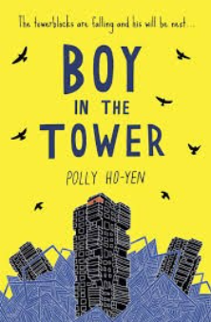 | Cogheeart by Peter Bunzl  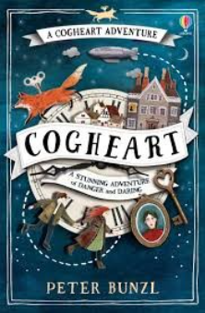 | No Ballet Shoes in Syria by Catherine Bruton  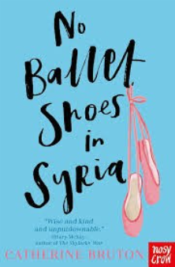 | The Girl of Ink and Stars by Kiran Millwood Hargrave  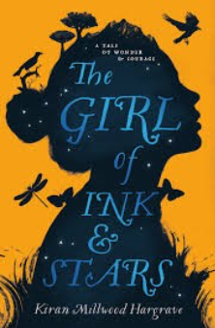
RFP |  |  | 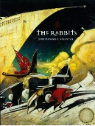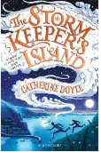 |  | 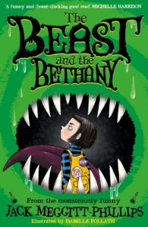
Writing | New CELT Writing Curriculum (being planned for mixed-age classes)
Maths Year 4 | Place Value (4 weeks)  Addition and Subtraction (3 weeks)  Measurement: Area (1 Week)  Multiplication and Division A (3 weeks) |  | Multiplication and Division B (3 weeks)  Length and Perimeter (2 weeks)  Fractions (4 weeks)  Decimals A (3 weeks) |  | Shape (2 weeks)  Decimals B (2 weeks)  Money (2 weeks)  Time (2 weeks)  Statistics (1 week)  Position and Direction (2 weeks)  Plus two consolidation weeks
Maths Year 5  *units moved for mixed age | Place Value (3 weeks)  Addition, subtraction (2 weeks)  Multiplication and Division A (3 weeks)  Perimeter and Area (2 weeks)  Volume (1 week) |  | Multiplication and Division B (3 weeks)  Fractions A (4 weeks)  Fractions B (2 weeks)  Decimals and percentages (3 weeks) |  | Shape (3 weeks)  Decimals (3 weeks)  Converting Units (2 weeks)  Statistics (2 weeks)  Position and Direction (2 weeks)  Negative Numbers (1 week)
Science  Year 4 units | If there is still a Year 4/5 Class, you will have to split to avoid repetition, as Year 5 will have done the Year 4 units in Year 3 and the new Year 4 will have done the Year 3 units in Year 3. Year 5 will need the Year 3 units as they have already done Y3 and Y4. Year 4 will need the Year 4 units as they have already done Y3.
History | If there is still a Year 4/5 Class, you will have to split to avoid repetition, as Year 5 will have done the Year 4 units in Year 3 and the new Year 4 will have done the Year 3 units in Year 3. Year 5 will need the Year 3 units as they have already done Y3 and Y4. Year 4 will need the Year 4 units as they have already done Y3.
Geography
RE
Computing  (Year 4 Units) | If there is still a Year 4/5 Class, you will have to split to avoid repetition, as Year 5 will have done the Year 4 units in Year 3 and the new Year 4 will have done the Year 3 units in Year 3. Year 5 will need the Year 3 units as they have already done Y3 and Y4. Year 4 will need the Year 4 units as they have already done Y3.
DT  Year 4 units |  | Cooking and Nutrition: Adapting a Recipe: Y4 |  | Structures: Helmets (Y4) |  | Mechanical Systems: Mechanical Cars (Y4 Kapow)
Art | Painting and Mixed Media: Light and Dark (Y4 Updated) |  | Craft and Design: Fabric Of Nature (Y4) |  | Sculpture and 3D: Interactive Installation (Y5)
Music
PE  Year 4 Units | Fundamental  Gymnastics | Dance  Invasion Games (Football) | Invasion Netball  Dodgeball | Net and Wall (Tennis)  Handball | Athletics  Yoga | Striking and Fielding (Cricket)  Fitness
MFL  (Year 4 units) | If there is still a Year 4/5 Class, you will have to split to avoid repetition, as Year 5 will have done the Year 4 units in Year 3 and the new Year 4 will have done the Year 3 units in Year 3. Year 5 will need the Year 3 units as they have already done Y3 and Y4. Year 4 will need the Year 4 units as they have already done Y3.

