
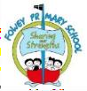
Fowey Year 2/3 Curriculum Overview Year B – 26-27

 | Autumn 1 | Autumn 2 |  | Spring 1 |  | Spring 2 |  | Summer 1 |  | Summer 2
Whole Class Reading  Y3 and off RWI Y2. | The Last Garden  The Good Deed Dogs  Amazing Animal Journeys  Momotato and the Oni (RWI)  Germs (RWI)  The Oak and the Reeds (RWI)  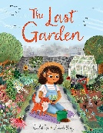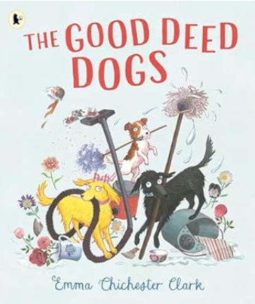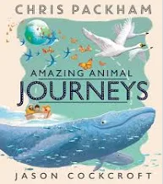 | The Hat full of secrets  Marge in Charge  The Proudest Blue  Traction Man is Here 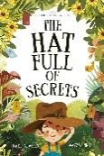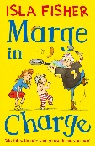  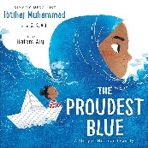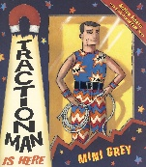 |  | Anisha Accidental Detective  Planet Omar – Accidental Trouble Magnet  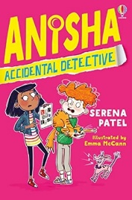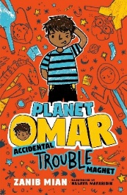 |  |  |  | Marv and the Dino Attack  The Great Food Bank Heist  The Nothing to See Here Hotel  Miraculous Journey of Edward Tulane  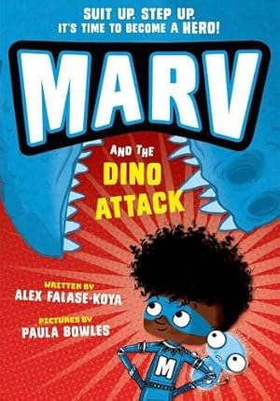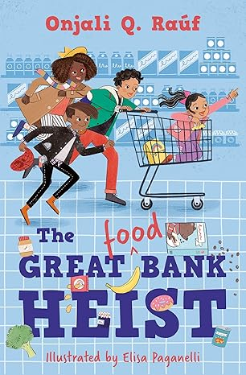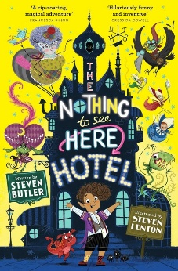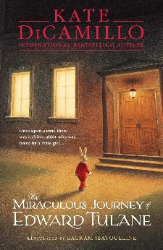
RFP | 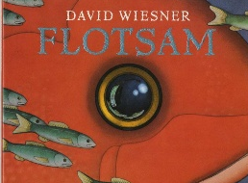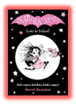 | 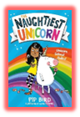 | 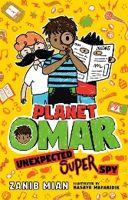 |  | 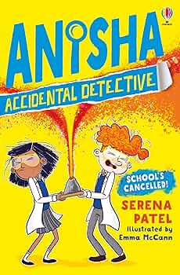 |  | 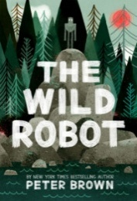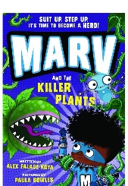
Writing | PVPG | PVPG Application Units. |  | New CELT Writing Curriculum (being planned for mixed-age classes)
Maths  (Y3) | NUMBER Place value  NUMBER Addition and subtraction  NUMBER Multiplication and Division |  | Number Multiplication and Division  Measurement Length and perimeter  Number Fractions A  Measurement Mass & Capacity  Number Fractions B |  |  |  | Measurement Time  Number Decimals  Measurement Money  Geometry Shape  Geometry Position and Direction  Statistics
Maths  (Y2) | NUMBER Place value  NUMBER Addition and subtraction  Measurement - Shape |  | Number Addition and Subtraction  Number Multiplication and Division  Measurement Length and height  Fractions |  |  |  | Time  Money  Mass, capacity and temperature  Geometry – Position and Direction  Statistics
Science  Year 3 units | Animals including humans.  - identify that animals including humans need the right types and amounts of nutrition, and that they cannot make their own food; they get their nutrition from what they eat.  - identify that humans and some other animals have skeletons and muscles for support, protection and movement. | Forces and magnets  - compare how things move on different surfaces.  - notice that some forces need contact between two objects, but magnetic forces can act at a distance.  - observe how magnets attract or repel each other and  attract some materials and not others.  - compare and group together a variety of everyday materials on the basis of whether they are attracted to a magnet and identify magnetic materials. | Light  - recognise that they need light in order to see things and that dark is the absence of light.  - notice that light is reflected from surfaces.  - recognise that light from the sun can be dangerous and that there are ways to protect their eyes.  - recognise that shadows are formed when light from a light source is blocked by an opaque object.  - find patterns in the way that the size of the shadows change. |  | Rocks  - compare and group together different kinds of rocks on the basis of their appearance and simple physical properties.  - describe in simple terms how fossils are formed when things that have lived are trapped within rock.  - recognise that soils are made from rocks and organic matter. |  | Plants  - identify and describe the functions of different parts of flowering plants: roots, stem/trunk, leaves and flowers.  - explore the requirements of plants for life and growth (air, light, water, nutrients from soil and room to grow) and how they vary from plant to plant.  - investigate the way in which water is transported within plants.  - explore the part that flowers play in the lifecycle of flowering
History  Year 3 units | Ancient Egypt | Cradles of Civilization | The Indus Valley |  | Persia and Greece |  | Ancient Greece |  | Alexander the Great
Geography  Year 3 units | Rivers | Mountains | Settlements |  | Agriculture |  | Volcanoes |  | Climate and Biomes
DT  Year 3 units |  | Structures: Product packaging  Coming soon! |  |  | Digital world: Wearable technology |  |  |  | Cooking and nutrition: Eating seasonally
Computing  Year | 3.2: Online Safety | 3.1: Coding  3.4: Touch typing | 3.5: Email |  | 3.3: Spreadsheets  3.8: Graphing |  | 3.6: Branching Databases |  | 3.7: Simulations  3.8 Presenting
Art  Year 3 units | Drawing: Developing drawing skills |  | Craft and design: Ancient Egyptian scrolls |  |  |  | Sculpture and 3D: Abstract shape and space
Music | Ballads | Creating Compositions in response to an animation | Developing singing technique |  | Pentatonic melodies and composition |  | Jazz |  | Traditional instruments and improvisation
PE  Year 3 Units | Fundamental  Gymnastics | Dance  Invasion Games (Football) | Invasion Netball  Dodgeball |  | Net and Wall (Tennis)  Handball |  | Athletics  Yoga |  | Striking and Fielding (Cricket)  Fitness
RE  Year 3 units | Hindu Stories | More Hindu Stories | Living Hindu Traditions |  | Abraham, Isaac and Joseph |  | Joseph, Moses and the Exodus |  | The kings, the temple and living as a Jew
MFL  (Year 3 units – only Y3) | French greetings with puppets | French adjectives of colour, size and shape | French playground games - numbers and age |  | In a French classroom |  | French transport |  | A circle of life in French
PSHE, SRE & Citizenship Year 3 do Year 3 units  Year 4 do Year 4 units. | Being Me in My World | Celebrating Differences | Healthy Me |  | Dreams and Goals |  | Relationships |  | Changing Me
Trips & Experiences  TBC | Paddle sports Intro session (both year groups) | Whole School Pantomime Trip | Humanities Workshop  Residential |  | Science Workshop |  | Heligan – Life in the jungle – survival in a super ecosystem |  | St Austell Festival of Children’s Literature  Careers fair

Fowey Year 2/3 Curriculum Overview Year A- 27-28

 | Autumn 1 | Autumn 2 | Spring 1 | Spring 2 | Summer 1 | Summer 2
Whole Class Reading | RWI Grey Book Focus. | The Pirates Next Door  The Polar Express  Claude in the City  The Dark  Fantastically Great Women  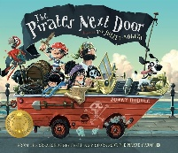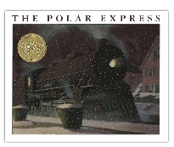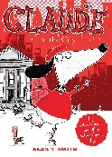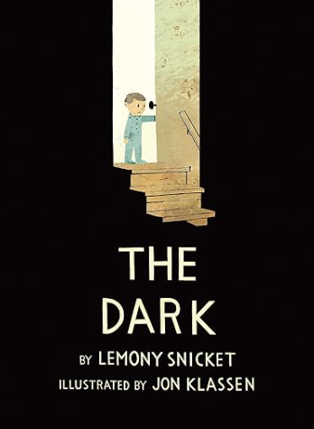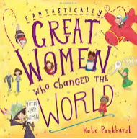 | Hodgeheg  The Naughtiest Unicorn  Leo and the Octopus (TTS)  Billy and the Dragon (TTS)  The Mud Maid  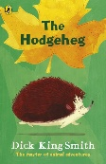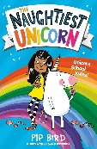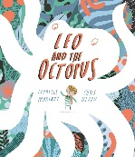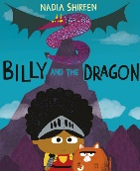 | The Dog That Saved Christmas  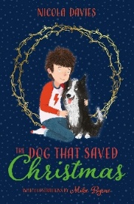 | The Mousehole Cat  Einstein the Penguin  Cornish Tales  Alien in the Jam Factory  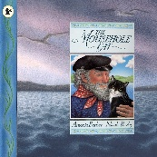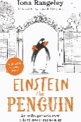  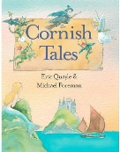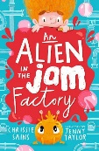 | Bertie and the Alien Chicken  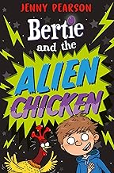
RFP | 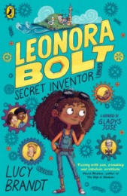 |  | 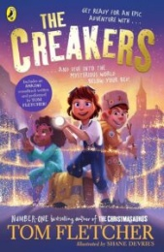 |  | 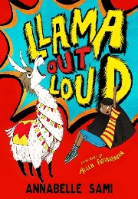
Writing | New CELT writing Curriculum
Maths  Y3) | NUMBER Place value  NUMBER Addition and subtraction  NUMBER Multiplication and Division  Measurement - Area |  | Number Multiplication and Division  Measurement Length and Perimeter  Number Fractions A  Measurement Mass & Capacity  Number Fractions B |  | Measurement Time  Number Decimals  Measurement Money  Geometry Shape  Geometry Position and Direction  Statistics
Maths  (Y2) | NUMBER Place value  NUMBER Addition and subtraction  NUMBER Place Value  Measurement - Shape |  | Number Addition and Subtraction  Number Multiplication and Division  Measurement Length and height  Fractions |  | Time  Money  Mass, capacity and temperature  Geometry – Position and Direction  Statistics

Science  Year 2 Units | Everyday materials  - identify and compare the suitability of a variety of everyday materials including wood, metal, plastic, glass, brick, rock, paper and cardboard for particular uses.  - find out how the shape of solid objects made from some materials can be changed by squashing, bending, twisting and stretching | Animals including humans  - describe the importance for humans of exercise, eating the right amounts of different types of food and hygiene. | Animals including humans  - notice that animals including humans have offspring, which grow into adults.  - find out about and describe the basic need of animals, including humans, for survival (water, food and air). | Plants  - observe and describe how seeds and bulbs grow into mature plants.  - - find out and describe how plants need water, light and suitable temperature to grow and stay healthy. | Living things and their habitats  - explore and compare the differences between things that are living, dead and things that have never been alive.  - identify that most living things live in habitats to which they are suited and describe how different habitats provide for the basic needs of different kinds of animals and plant and how they depend on each other. | Living things and their habitats  identify and name a variety of plants and animals in their habitats including microhabitats.  - describe how animals obtain their food from plants and other animals using the idea of a simple food chain and identify and name different sources of food.
History  Year 2 units |  | What was the Great Fire of London and how did it change London? |  | How did Mary Seacole and Florence Nightingale change nursing? |  | How has our local area changed?
Geography  Year 2 units | What is a map and how do use it? |  | What do homes look like around the world? |  | What are the physical features of our landscape?
DT  Year 2 |  | Cooking and Nutrition: Balanced Diet (Year 2 Kapow) |  | Structures: A chair for a bear (Year 2 Kapow) |  | Mechanisms: Fairground wheel (Year 2 Kapow)
Computing | 2.1 Coding  2.2 Online Safety | 2.3 Spreadsheets  2.4 Questioning | 2.5 Effective Searching  2.6 Creating Pictures | 2.7 Creating Pictures | 2.7 Making Music | 2.8 Presenting Ideas
Art | Drawing: Understanding tone and texture |  | Painting and mixed media: Life in colour |  | Sculpture and 3D: Clay Houses
Music  Kapow (Year 2) | Animals – call and response | Musical storytelling | On the island: singing | Space: Contrasting Dynamics | Myths and legends: Structure | Musical me: pitch

PE  Year 2 Units | Invasion Games  Fundamentals | Gymnastics  Fundamentals | Dance  Fundamentals | Net and Wall  Sending and receiving | Athletics  Sending and Receiving | Striking and Fielding  Target Games
RE  Year 2 units | Who do Christians say made the world? (Creation) Unit 8: | Why does Christmas matter to Christians? (Incarnation) Unit 9 | Who is Jewish and how do they live? (God, Torah, the People). | Unit 10  What do Christians  believe God is like?  (God) | Unit 11  What does it mean to  belong to a faith  community?  (Thematic) | Unit 12  How should we care for the world and for others, and why does it matter?  (Thematic)
MFL  (Year 3 units – only Y3) | French greetings with puppets | French adjectives of colour, size and shape | French playground games - numbers and age | In a French classroom | French transport | A circle of life in French
PSHE, SRE & Citizenship Year 3 do Year 3 units  Year 4 do Year 4 units. | Being Me in My World | Celebrating Differences | Healthy Me | Dreams and Goals | Relationships | Changing Me
Trips & Experiences | Paddle sports Intro session (both year groups) | Whole School Pantomime Trip | Dance around the world Workshop  Blast from the Past  Farm Visit  Residential | Climate Change Workshop | Heligan – Science by Observation Workshop | St Austell Festival of Children’s Literature  Careers fair

