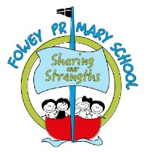

Fowey Year 1 Curriculum Overview

 | Autumn 1 | Autumn 2 | Spring 1 | Spring 2 | Summer 1 | Summer 2
RWI | Phonics: Children are assessed half-termly and placed in a group according to their ability. RWI is taught daily.  Pupils are taught daily by a Read, Write Inc. (RWI) teacher in groups organised by stage, not age. In addition, 10-minute daily 1:1 sessions take place to ensure that all pupils ‘keep up, not catch up’. Pupils are assessed ½ termly, progressing rapidly through the programme. When pupils progress off the RWI Programme, they begin Comprehension lessons using the RWI resource.
RFP | The Julia Donaldson Collection  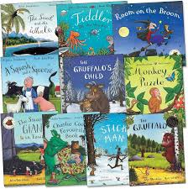 | 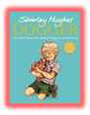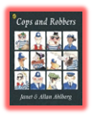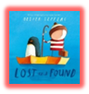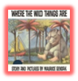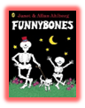 | 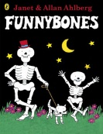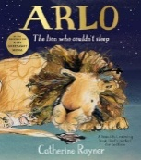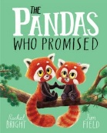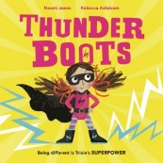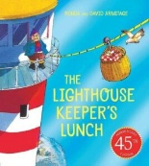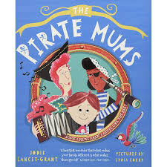 | 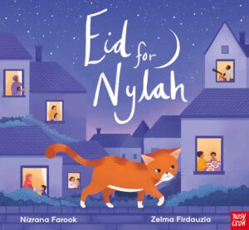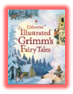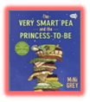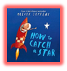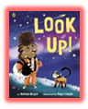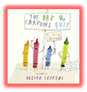 | Anthony Brown Collection  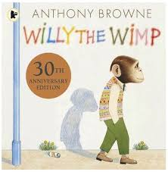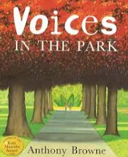  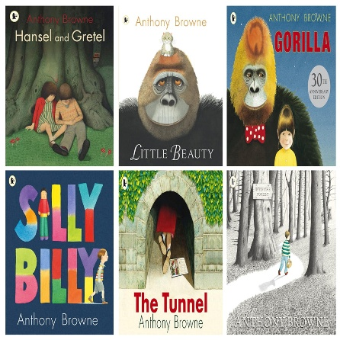 | 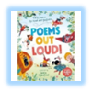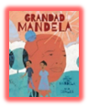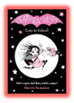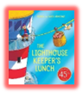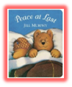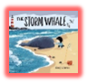
Writing | Drawing Club | Ready for PVPG | CELT Writing Curriculum
Maths | NUMBER – Place Value within 10 (5 weeks)  NUMBER: Addition and Subtraction within 10 (5 weeks)  Geometry: Shape (1 week)  Win 100-116 |  | Place Value within 20 (3 weeks)  Addition and Subtraction within 20 (3 weeks)  Place value within 50 (2 weeks)  Length and height ( 2 weeks)Mass and volume (2 weeks) Win 117-134 |  | Multiplication and division (3 weeks)  Fractions (2 weeks)  Geometry: Position and Direction (1 week)  Place Value within 100 (2 weeks)  Measurement: Money (1 week)  Measurement: Time (2 weeks) Win 135-150
History  Cycle A |  | How have toys changed? |  | Who were the explorers who changed our world? | How has our local area changed over time?
Geography  Cycle A | Where in the World are we? |  | What do homes and life look like around the world? |  |  | What is a map and how do we use it?
RE | Who Do Christians Say Made the World? | Why Does Christmas Matter to Christians? | Who Is Jewish and How Do They Live? | What Do Christians Believe God Is Like? | What Does It Mean to Belong to a Faith Community? | How Should We Care for the World and for Others, and Why Does It Matter?
DT |  | Structures: Stable Structures |  | Textiles: Simple Stitches |  | Mechanisms: Wheels and Arches
Art | Drawing: Exploring line and shape |  | Sculpture and 3D: Paper Play |  | Painting and mixed media: Colour splash
Computing | Unit 1.1  Unit 1.2 | Unit 1.3  Unit 1.4 | Unit 1.5  Unit 1.6 |  | Unit 1.7 | Unit 1.9
Science | Everyday Materials |  | Animals Including Humans |  | Plants
Science | Seasonal Changes
Music | My favourite things: Keeping the pulse | Snail and mouse: Tempo | Seaside: Dynamics | Fairytales: Sound patterns | Superheroes: Pitch | Under the sea: Musical symbols
PE | Gymnastics  Fundamentals | Invasion Games  Fundamentals | Dance  Fundamentals | Net and Wall  Sending and receiving | Athletics  Sending and Receiving | Striking and Fielding  Target Games
PSHE including SRE | Being Me in My World | Celebrating Differences | Dreams and Goals | Healthy Me | Relationships | Changing Me
Trips & Experiences |  | Whole school trip to Pantomime  Nativity | Dance around the world workshop  Toy making workshop | Trip to Lost Gardens of Heligan  From Seed to Harvest Workshop | Blast from the Past | St Austell Festival of Children’s Literature Author visit  Beach visit with EYFS  Career Fair

