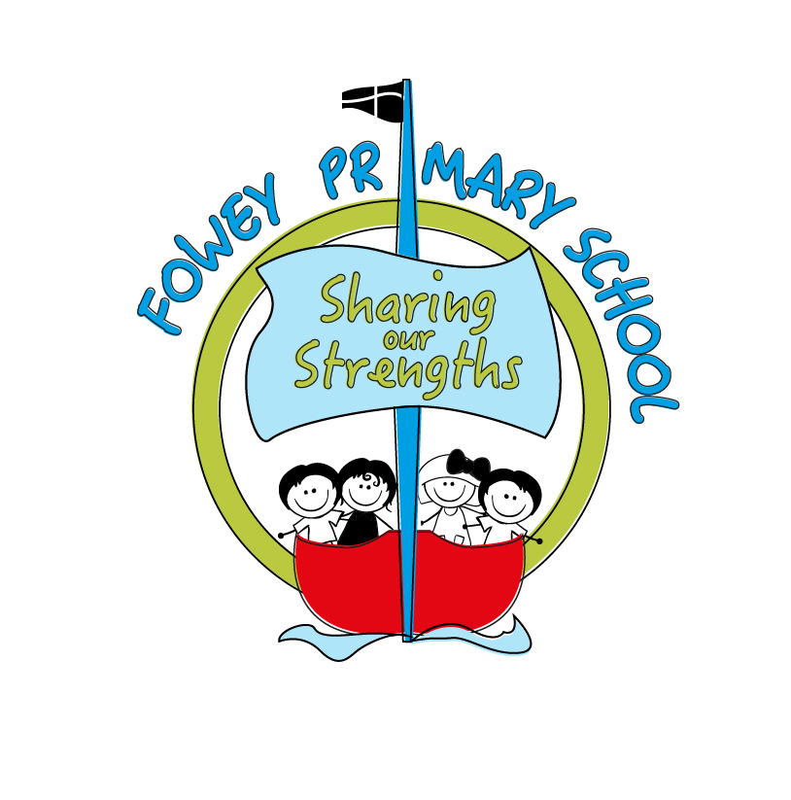Fowey Primary School

Academy Development Plan

2017-2018

|  |  |  |  |  |  |  |
| --- | --- | --- | --- | --- | --- | --- |
| **Focus/Target** | **Action to be taken** | **Who?** | **When/By?** | **Costs** | **Success criteria and termly evaluation** | **SC Monitored by?** |
| **SAFEGUARDING- Personal Development, Behaviour and Welfare** | | | | | | |
| Development points/actions arising from S175/157 return 2016/17 and other Safeguarding Actions | 1. Public Sector Equality Duty information to be updated on website. | KS | 1. Dec 2017 | none | Safeguarding systems are robust and S175/157 review/audit shows all actions have been followed up. | **Gov: Jaine Colwill** |
| 2. Audit all policies to ensure that all statutory policies are in place, are regularly updated or scheduled for review and that they are being implemented effectively and consistently. | KS | Dec 2017 | none |
| 3.Whole school display to overtly demonstrate how we keep everyone safe, as well as web pages with specific safeguarding information. | KS, JJ and MB | Dec 2017 | none |
| 4. DSL and Cover DSL Multi-agency Level 3 refresher training (Mental Health). | KS and MB | Dec 2017 (all staff have up-to-date training until 2018) | £45 pp |
| 5. Termly safeguarding updates including all inset days. | KS | Each inset day | none | Training record is maintained, all staff have attended at least two safeguarding training sessions in the year and ideally four. |
| 6. Audit HR files to ensure all safeguarding requirements are met and evidenced. | PLT (Rebecca Spencer) | Dec 17 | none | HR file spot-check is completed termly and cross referenced with information held on the SCR.  No errors are found. |
| 7. Introduce Chronologies for all safeguarding files to ensure that all actions are recorded | KS | Nov 17 | none | All files have updated chronologies which can be submitted to CP panels. |
| 8. Introduce E-Safety rules for KS1 and KS2. | KS and MB | Initial agreements out Sept 17, monitoring of children’s knowledge ongoing across year. | none | 98% of children have returned a signed e-safety agreement, class teachers have followed up verbally with parents who have not returned e-safety agreement.  Children are able to articulate the e-safety rules and why they are important. |
| 9. Improve children’s awareness of Safeguarding and, in particular, E-Safety. | KS and MB | July 2018 | none | Safeguarding forms the focus of at least one assembly per term.  Safeguarding themes are included in the curriculum review and are planned into the new curriculum strategy for 2018-2019.  All children have accessed NSPCC Pants Rule lessons or Speak Out, Stay Safe workshops. |

|  |  |  |  |  |  |  |
| --- | --- | --- | --- | --- | --- | --- |
|  | **Action to be taken** | **Who?** | **When/By?** | **Costs** | **Success criteria** | **SC Monitored by?** |
| **Quality of Teaching, Learning and Assessment – outcomes for pupils** | | | | | | |
| Improve progress of children who have achieved at greater depth combined in KS1. | Six weekly pupil progress meetings, to include a focus on improving progress for previously higher attainers. | KS/MB | Each half term | none | End of KS2- 50% of children who have previously attained greater depth, attain greater depth again in each single strand.  40% of children who have previously attained greater depth in two or more strands, to achieve greater depth in RWM combined,.  End of KS1- Ensure that 80% of children who were exceeding in RWM in EYFS achieve RWM combined at greater depth in Year 2. Ensure that 80% of children who were exceeding in one or two specific areas (e.g. writing, reading) are exceeding in those areas.  In Year 3, 80% of children who achieved at greater depth in RWM or a single strand to achieve greater depth again in RWM or that single strand.  In Year 4 and Year 5, 70% of children who achieved at greater depth in KS1 (either combined RWM or a single strand) to achieve at greater depth in RWM or a single strand. I  In Year One, all children who achieved a good level of development to achieve expected. All children who achieved at greater depth, to achieve at greater depth. | **Gov:** Chris Williams |
| Maths CPD to focus on challenge, reasoning and problem solving skills for previously high attainers. | MB | Autumn 2 | none |
| Writing at Greater Depth focus for Inset- October 2017 and CPD Spring One | KS/PT | Autumn Two and Spring One | TBC |
| Close data scrutiny of Year 3 and Year 4, to ensure children do not begin a gradual slip from greater depth in Y2. | PT | ongoing | £150 Jason Hurr |
| Close data scrutiny of current Year 6 to target children who need to make accelerated progress. | PT | ongoing | £150 Jason Hurr |
| Improve whole school attendance | Create an attendance policy and make available on school website. | KS | Autumn 1 | none | Whole school attendance average is above 97% and that persistent absence is less than 5%.  Class Targets:  Lantic- 96.5%  Cannis- 96.5%  Gribben- 97%  Coombe- 97.5%  Readymoney-97.5%  Polridmouth- 97%  Carne- 97.5%  Children who are persistently absent (and who do not have additional needs which mitigate this) have a received an education planning meeting with Cornwall Council. | **Gov:** Jaine Colwill and Natalie Pepperell (behaviour) |
| Create an attendance procedure and set of model letters to challenge non-attendance, share via website. | KS | Autumn 1 | none |
| Write to all families to highlight attendance targets this year and write again to families when a child’s attendance hits trigger points. | Office | Autumn 1 | none |
| Review, with PVG, rewards for good attendance. | KS | Autumn 2 | none |
| Registers to be taken online so that patterns can quickly be spotted and challenged. | Office | Autumn 1 | none |
| Each class to be set an attendance target, to form part of teacher performance management. | KS | Autumn 1 | none |
| Children who have previously been persistently absent to be targeted in September 2017 and any absences challenged robustly. | KS/Office | September 17 | none |
| **Curriculum Review:**  **Review all aspects of the curriculum to devise a new curriculum overview for 2017-2018.** | 1. Consultation with parents, staff and school community and creation of new SRE policy to reflect British Values and e-safety. | KS | Jan 18 | none | New curriculum model to be launched in 2018-2019 | **Gov:** Kay Peacey (eng), Kay Taylor (ma) and Chris Williams (standards) |
| 2. Review the school’s vision and values, re-launching a new vision and values after consultation. | KS | Autumn 1 | £100- branding |
| 2. New teaching and learning policy. | KS | Ready for July 18, implemented September 2018. | none |
| 3. Revised curriculum for 2018-2019 to be devised, ensuring that PSHE, British Values, Safeguarding and Computing are embedded rather than stand-alone add ons | KS/MB/PT/EW/ JJ | TBC |
| 4. All teaching staff given the opportunity to visit outstanding schools locally and nationally and feedback on different curriculum models. | KS | July 18 | £1000 travel |
| 5. Review of Inspire Curriculum. | EW/KS | Spring 1 | none |
| 6. Review of English Curriculum. | PT | Autumn 2 | none |
| 7. Review of Maths Curriculum. | MB | Spring 1 | none |
| 8. Review of Science Curriculum. | EW | Spring 2 | none |
| 9. Review of SRE, PSHE and British Values teaching. | VO and JJ | Spring 1 | none |
| 10. Review of Wednesday Workshops to ensure progression in learning and skills. | PC/KS | Autumn 1 | none |
| 11. Review of homework policy, home reading and spellings. | KS | Autumn 2 | none |
| 12. Review of parental engagement with learning. | KS | Spring 2 | none |
| **English: Reading**  Implement whole class reading in KS2 and continue to monitor the success of RWI in KS1.  **Phonics**  Continue to closely monitor RWI phonics to ensure improvements seen in 2016-2017 are sustained. | 1. Consultation with parents, staff and children to create a canon of books for Fowey (to be refreshed every two years. | PT/KS | Autumn 1 | £2500 for new books | **Reading Outcomes:**  **% of children achieving at expected standard in reading:**  Lantic- 85% GLD  Cannis- 85%  Gribben- 90%  Coombe-85%  Readymoney- 90%  Polridmouth-85%  Carne- 87%  % of children achieving at greater depth in reading:  Lantic- 20% exceeding GLD  Cannis- 25%  Gribben- 30%  Coombe- 35%  Readymoney- 35%  Polridmouth- 28%  Carne- 25% | **Gov:** Kay Peacey (eng) |
| 2. Staff training in whole class reading. | KS | Sept 17 | none |
| 3. Shared strategy for the effective teaching of whole class reading developed and articulated by children, parents and staff. | PT | ongoing | none |
| 4. Monitoring of whole class reading and RWI through scheduled learning walks and pop-ins. Ensuring a high standard of questioning and challenge. | PT/KS | ongoing | none |
| 5. SEND children identified for pre-teaching, which allows them to participate regularly in whole class reading session. | MB/PT | ongoing | £1000 teaching assistant salaries |
| 6. Middle Leader trained in effectively monitoring whole class reading and coaching staff to improve outcomes. | KS/PT | July 18 | none |
| 1. Ensure a high standard of RWI delivery is maintained. | JJ | Dec 17 | none | Phonics screening check scores to be at least 90%.  **EYFS**  **Autumn 1** - 30% Secure within section A  **Autumn 2** - 80% Secure at section A  **Spring 1** - 30% Secure at section B  **Spring 2** - 80% Secure at section B - 10% Exceeding section B  **Summer 1** - 85% Secure at section C - 50% Secure at section D  **Summer 2** - 85% Secure at section D - 10% Exceeding section D  **Year 1**  **Autumn 1** - 60% Secure at section E  **Autumn 2** - 100% Secure at section E  **Spring 1** - 30% Secure at section F  **Spring 2** - 75% Secure at section F  **Summer 1** - 80% Secure at section G - 10% Secure at section H  **Summer 2** - 85% Secure at section I -15% Secure at section J  **Year 2**  **Autumn** - 70% Secure at section J  **Spring** - 90% Secure at section J and having progressed onto RWI Spelling.  **Summer** – 90% of children working at age related expectations.  Phonics screening retake - 90% | **Gov:** Kay Peacey (English) and Sinead Hanks (EYFS) |
| 2. All groups of learners (including interventions) are consistently planned for. | JJ | ongoing | none |
| 3. Targeted home/school liaison for children who are below age related expectations. | JJ | October 17 | none |
| 4. Morning and evening parent/child workshops to introduce RWI to parents | JJ | Nov 17 | none |
| 5. Teachers provide opportunities to consolidate/reinforce/extend learning outside the phonics/spelling session. | JJ | Dec 17 | none |
| 6. Invite pre-school leaders to visit school and observe the teaching of RWI phonics. | JJ | Spring 1 | none |
| 7. RWI Phonic resources/flashcards to be given to pre-school at the beginning of the summer term to be used to support phonic development. | JJ | Summer 1 | none |
| 8. Observations and moderation to ensure consistency of approach to the teaching of RWI phonics in KS1/EYFS, to include video analysis and sharing of practice. | JJ/KS | ongoing | none |
| English Writing | 1. Increased observations of writing scrutiny through monitoring cycle. | PT/KS | Autumn One | none | **Writing Outcomes:**  **% of children achieving at expected standard in writing:**  Lantic- 85% GLD  Cannis- 80%  Gribben- 75%  Coombe-80%  Readymoney- 75%  Polridmouth-78%  Carne- 80%  % of children achieving at greater depth in writing:  Lantic- 20% exceeding GLD  Cannis- 20%  Gribben- 17%  Coombe- 20%  Readymoney- 25%  Polridmouth- 20%  Carne- 20% | **Gov:** Kay Peacey (eng) |
| 2. Writing to be included as a specific strand in pupil progress meetings. | KS | Autumn Two | none |
| Review of writing curriculum in Autumn 2 and action points urgently reviewed. | PT | Autumn Two | none |
| Writing CPD focus | PT | Spring One | TBC |
| All teachers to receive a writing target as part of performance management. | KS | Autumn One | none |
| Introduce annual Cartonera writing festival to increase sense of writing for a purpose. | KS/PT | Spring One | £150 |
| Targeted ‘Inspirational Writing’ experiences and events for Pupil Premium children | KS/PT | Autumn Two | £2000 | The percentage of premium children working at expected or greater depth in writing will be at least in line with national standards (currently -0.3). |
| Targeted assisted technology, IT (laptops and IPads) for SEND children to assist writing. | MB | Autumn Two | £2000 | The gap in attainment of expected between SEND children and their peers will be narrowed (currently -7%) as children who find writing mechanically difficult will be supported to record in alternative ways. These children will report more positive experiences of writing. | **Gov:** Lucy Elliott |

|  |  |  |  |  |  |  |
| --- | --- | --- | --- | --- | --- | --- |
| **EFFECTIVENESS OF EARLY YEARS PROVISION** | | | | | | |
| Outcomes for Pupils: | 1. Improve and plan for outdoor area to be used daily, in all weathers, to ensure that all areas are provided in both outdoor and indoor environments. Improve opportunities for physical development in the outdoor area. | JJ | Autumn One | £2000 | 85% of children to achieve GLD, 20% at greater depth.  Speaking- 90%  Managing Feelings and Behaviour- 90%  Reading- 90%  Writing- 90%  There will be no significant gap between the attainment and progress of boys and girls.  !00% of pupil premium children will achieve a good level of development. | **Gov:** Sinead Hanks |
| 2. Ensure that writing opportunities are always provided and planned for both inside and outside. | JJ | Autumn Two | £500 |
| 3. Introduce loose parts play to provide increased challenge to play. | JJ/KS | Spring One | £500 |
| 4. Increase opportunities for child initiated learning, using in the moment planning | JJ | Autumn Two | none |
| 5. Ensure effective and accurate assessment of children based on high quality observations from all involved in children’s development, including parents and support staff. | JJ | Autumn Two | £120 TA training course |
| 6. Ensure that 100% of pupil premium children achieve a good level of development | JJ | by Summer Two | Pupil Premium Funding- targeted as needed |