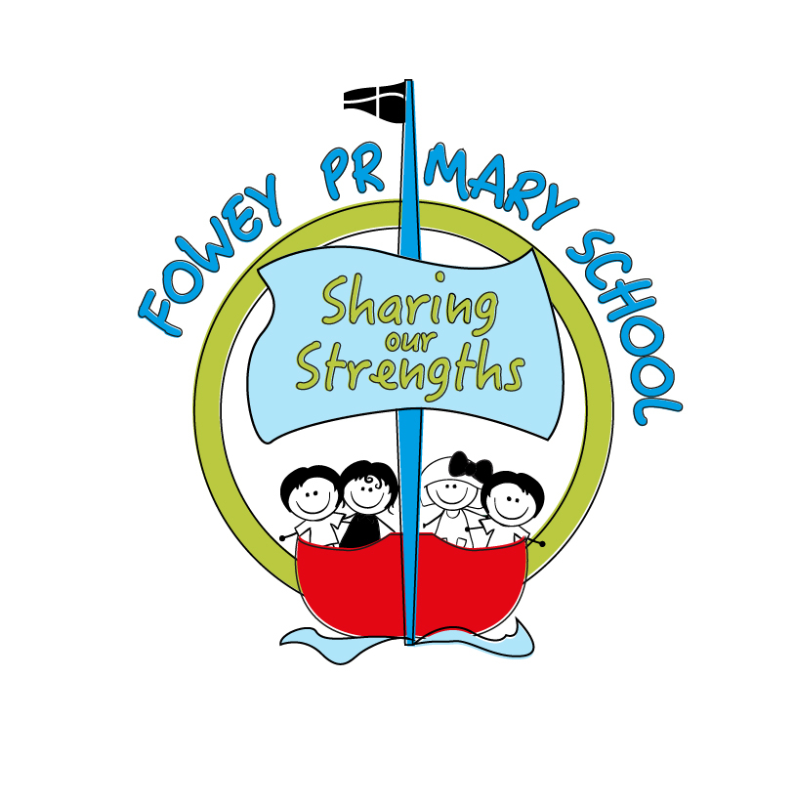
Headteacher’s Message

Fowey Primary School
Newsletter 4: 17th November 2017
We have had a great week at Fowey, highlighting bullying of all kinds as part of national anti-bullying week. Learning about bullying is integrated into our PSHE (personal, social, health education) curriculum programme but it is always incredibly valuable to have weeks, such as this, to highlight important issues further.

The theme this year has been 'all different, all equal' and the children have enjoyed learning about the huge range of difference and diversity that exists in our world.

We hope you will support us in encouraging all the children to talk about how we are different. As we highlight in our vision, we are all different but we fit together.

I am also very pleased to see how popular our Christmas production has been, it will be wonderful to have such support for our fantastic children. We will be offering any leftover tickets to any parents from next Wednesday, 22nd November.

Have a lovely weekend,

Kate

PS- It is very common following weeks such as anti-bullying week to see an increase in children talking about bullying. This usually occurs simply because we have highlighted the issue and so it is at the forefront of children's minds rather than because there has been an increase in instances of bullying, which at Fowey are rare. Please do feel free to speak to your child's class teacher if you have any concerns.

Lantic
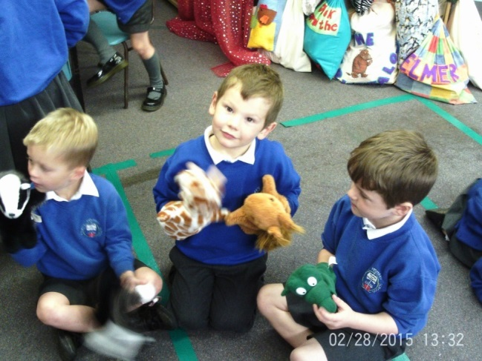

The children in Lantic had fun using the puppets to tell a story about how we are different and how we can make friends. We spoke about what we can say that would make us a kind friend and what we can do if we see someone on their own.

Cannis
This week in Cannis we have discussed what bullying is and role-played situations which could be seen as bullying. We learnt how to be a good friend and who we can talk to when we are troubled.
We also began learning our snowflake song and created actions. What a busy week in Year 1!
Gribben
This week we have been exploring what bullying means through a range of different activities. The pupils recognised and celebrated difference and thought how someone who is being bullied might feel. We also discussed who they might tell if they were being bullied.
Coombe
Coombe class are very excited because they have been selected to decorate a Christmas tree for the Eden Project. Last week, the children held a Christmas themed tea party where adults of the community came together to discuss with the children their Christmas memories. The children had a wonderful time discussing and looking at all the old-fashioned decorations and toys; this has given them a lot to think about and has inspired lots of ideas. Thank you to all the adults that came! Coombe class will be making their decorations next week. If there are any adults who would like to help, please let me know.
Readymoney

In Readymoney this week, we have been thinking about what bullying is, as well as what it isn't. We watched two different video clips and thought about the roles different people can play if we see bullying happening. We also considered what to do if cyber bullying was happening online.

Polridmouth and Carne

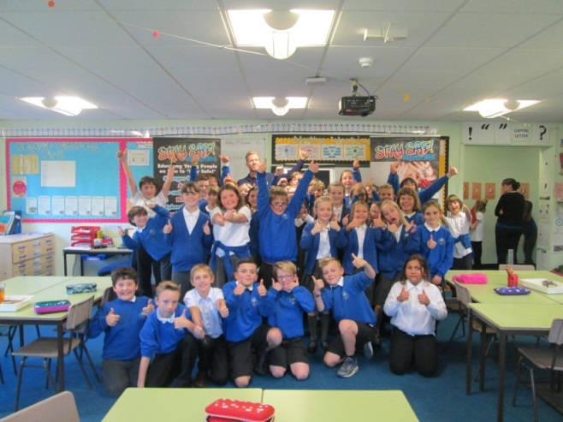
We had an anti-bullying workshop from Richard (Stay Safe Workshop). We learnt about the types of bullying, what bullying is, how we can stop it, what we should do if we're being bullied. We had fun doing a toothpaste challenge and acting out situations.

“On Monday a visitor came to our class about anti bullying week we did challenges like the tooth paste challenge. We were told lots of things. There are four types of bullying, Physical, Social, Cyber and Verbal bullying. The golden rule was to speak up and tell someone.” By Jake, Chloe and Kerris.

Oceans
Thank you to everyone who ensures that their Parent Pay account for Oceans is balanced or in credit. Unfortunately, there are a few families whose accounts are in very significant debit. As I'm sure you will have heard, school budgets are exceptionally tight and we cannot allow families to build up significant debts. Therefore, from January, we will not allow any families to book more Oceans sessions who have a debt of more than £20.

If you are experiencing financial difficulties and this is making it hard for you to keep up with payments for Oceans please come and speak to me. All conversations will, of course, be confidential.

Recruitment

Due to retirement and a wish to reduce hours, we are currently recruiting for a site manager, cleaner and a teaching assistant. All vacancies are available on the Cornwall Council website.

SATS information evenings

A huge thanks to all families who have attended and will be attending our SATS information sessions for Year 2 and Year 6, which we hope you find useful. We will run more sessions later in the year on how you can support your child and we would appreciate any feedback as to how we can make these sessions most beneficial. Please chat to Mrs Warnham or Ms Barnes if you have any suggestions.
KS2 Reading

Alongside many schools nationally we are currently reforming the way we teach reading in KS2, moving from a traditional guided reading model to a whole class approach. This is because the expectation in the new curriculum has shifted to require that children experience whole novels and texts, which is impossible in a short session once a week with an adult. We also believe that whole class reading provides more challenge to reading and ensures that all children read in school more regularly.

The children are very positive about the change and have loved experiencing their new books.

As part of this, you should have received a letter asking for any suggestions of books you feel would be beneficial for all children to read. Please feel free to suggest books you loved as a child, as well as books your children have loved and books which you feel are great teaching tools.

We want to take this opportunity to really create the right set of books for Fowey children, books which teach about the world but also books which allow our children to think about who they are and what matters to us.

We will share the finalised reading list with you at the end of term and it will be refreshed every couple of years to ensure it remains relevant.

Sickness and Diarrhoea

I have received comments from several parents that the blanket policy of not allowing children to return to school after sickness for 48 hours, is unhelpful. I understand that this is because children are sometimes sick (e.g. asthmatic children or small children who have done a lot of exercise but are showing no signs of infection or illness) but are not allowed to return to school irrespective of the reason for sickness.

Although it is guidance from the Health Protection Agency that children do not return to school for 48 hours, it is not statutory and I understand many schools now adopt a case by case approach which seems to me to be sensible.

In line with this, from next week, the office staff will discuss your child's sickness with you when you phone. If it is clear that your child is showing signs of an infection or virus then they should remain at home so the germs are not spread through the whole community. However, if you feel your child is not infectious and is well enough to return to school please let the staff know and they will make a sensible decision with you.

If you have any questions about this, please speak to Mrs Sicolo or your child's class teacher.

Current league tables for the football and netball standings

Year 5/6 League Table  Team P W D L Pts  Fowey 5 5 0 0 15  Charlestown 4 2 1 1 7  Bishop Bronescombe 3 2 0 1 6  Tywardreath 3 2 0 1 6  Mevagissey 4 1 0 3 3  Lostwithiel 3 1 0 2 3  Pondhu 3 0 1 2 1  Gorran 3 0 0 3 0 | Year 3/4 League Table  Team P W D L Pts  Fowey 5 4 1 0 13  Bishop Bronescombe 3 2 0 1 6  Pondhu 3 1 2 0 5  Charlestown 4 1 2 1 5  Tywardreath 3 1 2 0 5  Lostwithiel 3 1 1 1 4  Mevagissey 4 0 0 4 0  Gorran 3 0 0 3 0 | Netball League Table  Team P W D L Pts  Fowey 5 5 0 0 15  Bishop Bronescombe 3 3 0 0 9  Pondhu 3 2 0 1 6  Mevagissey 4 2 0 2 6  Gorran 3 1 0 2 3  Lostwithiel 3 1 0 2 3  Tywardreath 3 0 0 3 0  Charlestown 4 0 0 4 0

