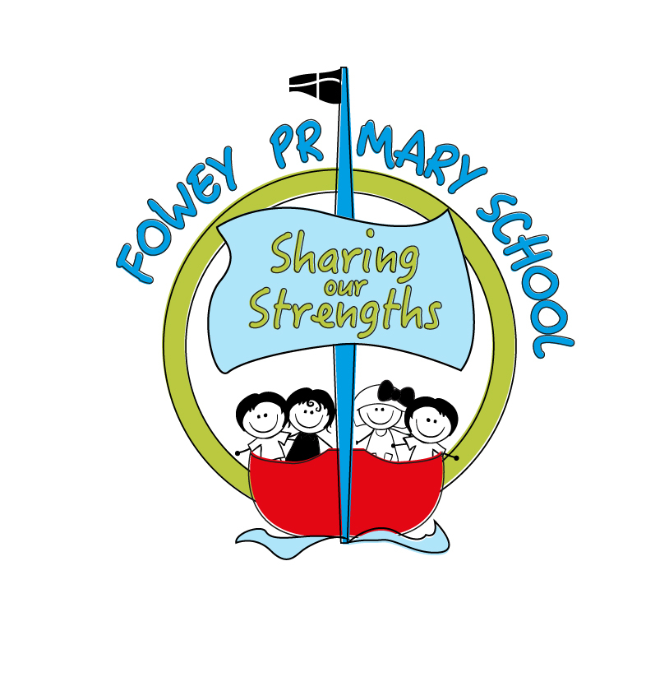
Headteacher’s Message

Fowey Primary School
Newsletter 3: 10th November 2017
What a busy second half to the term we have had at Fowey Primary School!
Wind In The Willows rehearsals are in full swing and no doubt you will soon start to hear songs being sung around the house as your children start practising their class songs. The year 6 children have their scripts and are learning their lines, please do encourage them to practise at home. Tickets will be on sale next week to the whole school on Wednesday, Thursday and Friday in the Library. Please drop your children off to class first before joining the queue to purchase them.
Kate

Fundraising for The Brain Tumour Charity

We are delighted to be supporting local young man, Ollie Jowett, in his efforts to raise money for The Brain Tumour Charity. Ollie was a pupil at Fowey Primary, as were both of his sisters, and his family live locally. Ollie has been diagnosed with a stage two brain tumour and is aiming to raise £5000 for this charity. We will be holding a sponsored fun mile on the 29th November (or 30th if wet) to help with his fundraising efforts. More details will follow next week.
PS- As we are supporting a local cause this month, we will not be participating in BBC Children in Need at school this year.

Retirement

This week we have said good-bye to Ros Hayward who has retired. Ros has been working in the office on Wednesdays and Thursdays for about the last year. We hope that she enjoys a relaxing retirement with her beloved pets. A new temporary admin assistant, Ellen Richards, will be joining us from next week. We hope you'll join with us in welcoming Ellen to the Fowey team.
Carne
In Carne, we have been learning the story of Wind in the Willows and we have started rehearsals for the Christmas play. On Thursday we went to the river bank to inspire our creative writing! Thank you to Fowey Hotel who let us enter their Wind in the Willows garden.
Look out for samples of our work on display soon.
Coombe
Coombe class are very excited because they have been selected to decorate a Christmas tree for the Eden Project. Last week, the children held a Christmas themed tea party where adults of the community came together to discuss with the children their Christmas memories. The children had a wonderful time discussing and looking at all the old-fashioned decorations and toys; this has given them a lot to think about and has inspired lots of ideas. Thank you to all the adults that came! Coombe class will be making their decorations next week. If there are any adults who would like to help, please let Miss Oatham know.
Polridmouth.

This week we have been writing our next part to our Greek Myths for our Topic work on Ancient Greeks, we have also practised our Handwriting in English by sending letters out to different companies asking if they would be able to donate towards our Christmas Tree for the Hall.

Remembrance Service

This Saturday the school Choir will be taking part in the Remembrance Service at Fowey Church. The Children need to be at the church for 7pm with a start at 7:30pm. Everyone is welcome to come along. Tickets are £5 and can be purchased from Bookends in Fowey.

Football/ Netball matches.
This week, our football and netball teams maintained their unbeaten start to the season with 2 victories and a draw against strong Tywardreath sides. The Year 3/4s showed great team spirit to come from behind twice and earn a 2-2 draw. A special mention must go to Harry who stood in as a goalkeeper and made some incredible saves!
The Year 5/6 team also battled well in tough, wet conditions. They managed to get the 4-2 win, with some great team goals once again.
The netballers also remain top of the table thanks to an impressive 9-2 victory with excellent passing skills on display. Well done to all!

Flu Vaccines
Just a reminder that children in classes Reception to Year 4 will be having their Flu Vaccines on Friday 17th November. This will be done in the morning during school time.
Bike Ability.
Next Friday is the start of Year 6’s Bike Ability, this will be happening over the next four Fridays. We are in need of an extra adult to help on these days, if you are free to help and are one of our registered Volunteers, please speak to Mrs Warnham, to arrange dates and times. You do not need to be a parent of Year 6 child to help. You will need your own bike for some of the sessions. Many thanks.

